A structured approach to water management of a multiuse reservoir

Final Report

2021

Victoria R. Starnes

Submitted to U.S. Fish and Wildlife Service

Sam D. Hamilton Noxubee National Wildlife Refuge

Brooksville, MS

TABLE OF CONTENTS

LIST OF TABLES v

LIST OF FIGURES vi

CHAPTER

1. A DECISION SUPPORT TOOL EVALUATING ALTERNATIVE WATER MANAGEMENT STRATEGIES FOR A MULTIUSE RESERVOIR 9

1.1 Introduction 9

1.2 Study Area 11

1.3 Methods 14

1.3.1 General Overview 14

1.3.2 Defining objectives and linking to water surface elevation 15

1.3.2.1 Calculating water volumes at varying water surface elevations 15

1.3.2.2 Linking management objectives to water surface elevation 17

1.3.2.2.1 Linking waterfowl objectives to water surface elevation 17

1.3.2.2.2 Linking wading bird objectives to water surface elevation 18

1.3.2.2.3 Linking fishery objectives to water surface elevation 19

1.3.2.2.4 Linking fish assemblage objectives to water surface elevation 19

1.3.2.2.5 Paddlefish objectives 21

1.3.3 Creating A Hydrodynamic Lake Level Model (HDLLM) to simulate water surface elevation 21

1.3.3.1 Using water level monitoring to calibrate the HDLLM 21

1.3.3.2 Quantifying Bluff Lake hydrodynamics 23

1.3.3.2.1 Inflow modeling 23

1.3.3.2.2 Outflow modeling 24

1.3.3.2.3 Modeling Bluff Lake Dynamics 25

1.3.3.2.4 Validating Water Level Dynamics. 25

1.3.3.3 Combining lake volume dynamics and alternative water level management actions 26

1.3.4 Evaluating discharges by linking water surface elevation to objectives 27

1.4 Results 31

1.4.1 Defining objectives and linking to water surface elevation 31

1.4.1.1 Calculating water volumes at varying water surface elevations 31

1.4.1.2 Linking management objectives to water surface elevation 31

1.4.2 Creating A Hydrodynamic Lake Level Model (HDLLM) to simulate water surface elevation 32

1.4.2.1 Validating Water Level Dynamics. 32

1.4.3 Evaluating discharges by linking water surface elevation to objectives 32

1.5 Discussion 34

Tables 41

Figures 43

References 63

APPENDIX

* + 1. REFUGE OBJECTIVES OBTAINED FROM THE 2014 CONSERVATION PLAN FOR SAM D. HAMILTON NOXUBEE NATIONAL WILDLIFE REFUGE 68

APPENDIX

* + 1. ADDITIONAL FISHERY INFORMATION 71

Tables 73

APPENDIX

* + 1. ESTIMATING PARAMETERS FOR THE BLUFF LAKE DISSOLVED OXYGEN MODEL 74

C.1 Introduction 75

C.2 Methods 76

C.2.1 Estimating water column respiration (WR) 76

C.2.2 Estimating sediment respiration (SR) 76

C.2.3 Calibrating the thickness of the air-water boundary ($k$) 77

C.2.4 Model Validation 77

C.2.5 Model Application 78

C.3 Results 78

C.3.1 Estimating WR, SR, and $k$ 78

C.3.2 Model Validation and Application 78

C.4 Discussion 79

Tables 80

Figures 81

References 88

APPENDIX

* + 1. ANALYSIS OF HYDROLOGICAL PATTERNS OF THE NOXUBEE RIVER NEAR MACON, MS 89

D.1 Introduction 90

D.2 Methods 90

D.3 Results 90

D.3.1 Identify trends in high and low discharge patterns within and among years 90

D.3.2 Describe the seasonality of high and low flow events 91

D.3.3 Describe patterns in the frequency and duration of high and low flow events 91

D.4 Discussion 92

Figures 94

APPENDIX

* + 1. INSTANTANEOUS COUNTS 108

E.1 Introduction 109

E.2 Methods 109

E.3 Results 111

Figures 113

References 125

APPENDIX

* + 1. ADDITIONAL RESERVOIR USAGE INFORMATION 126

Figures 128

LIST OF TABLES

Table 1.1 List of models and equations used in this paper. 41

Table 1.2 Dissolved Oxygen Criteria for Nonsalmonid Waters (Adapted from EPA 1986). 42

Table B.1 Family, scientific name, common name for fish collected from Bluff Lake, MS from 2019-2020. 73

Table C.1 Table of the equations and components used within the dawn dissolved oxygen model developed in Miranda et al. (2001). 80

LIST OF FIGURES

Figure 1.1 Map of Bluff Lake, Sam D. Hamilton Noxubee National Wildlife Refuge 43

Figure 1.2 Drawdown schedule by date for Bluff Lake, Sam D. Hamilton Noxubee National Wildlife Refuge 44

Figure 1.3 Decision model outline 45

Figure 1.4 Bathymetric mapping transect map 46

Figure 1.5 Outline of refuge objectives related to the water level management 47

Figure 1.6 Map of accessible bank areas and boardwalks for fishing 48

Figure 1.7 Map of water level logger deployment locations 49

Figure 1.8 Conceptual diagram of utility calculations 50

Figure 1.9 Plots of seasonal weighting applied to refuge objective metrics. 51

Figure 1.10 Lakebed elevation map 52

Figure 1.11 Water surface elevation and water volume relationship 53

Figure 1.12 Plots of calculated objective metrics assigned to each objective. 54

Figure 1.13 Spatial plot of dawn dissolved oxygen (DO) modeled within a vertical profile 55

Figure 1.14 Predicted water surface elevation at lake inflow by Julian day of year 56

Figure 1.15 Modeled water surface elevation of Bluff Lake by Julian day of year 57

Figure 1.16 Line plot of modeled water surface elevation of Bluff Lake by hour 58

Figure 1.17 Line plot of modeled lake volume for Bluff Lake by hour with additional 8-hour discharges 59

Figure 1.18 Cumulative daily utilities by Julian day of year 60

Figure 1.19 Optimal discharge strategies by drawdown period with drawdown implementation 61

Figure 1.20 Optimal discharge strategies by drawdown period without water drawdown 62

Figure C.1 Water quality sampling points 81

Figure C.2 Comparison of water column respiration of vegetated and open water areas 82

Figure C.3 Sediment respiration rates by water temperature 83

Figure C.4 Comparison of true and modeled dissolved oxygen including depth 84

Figure C.5 Comparison of true and modeled dissolved oxygen including water temperature 85

Figure C.6 Water volume with dissolved oxygen (DO) concentrations > 5-mg/L modeled at dawn given starting dusk temperature 86

Figure C.7 Water volume modeled with dissolved oxygen (DO) concentrations > 5-mg/L at dawn given starting dusk dissolved oxygen 87

Figure D.1 90th percentile break in average daily discharge for each water year 94

Figure D.2 Annual cumulative 90th percentile of daily discharges for each water year 95

Figure D.3 10th percentile of discharge events by water year 96

Figure D.4 Annual cumulative 10th percentile of discharges by water year 97

Figure D.5 High discharge events from 1945 to 2020 by day of water year 98

Figure D.6 Low discharge events from 1945 to 2020 by day of water year 99

Figure D.7 Frequency of high flow days per water year 100

Figure D.8 Frequency of high flow events per water year 101

Figure D.9 Duration of high flow events by water year 102

Figure D.10 Trends in duration of high flow events by water year 103

Figure D.11 Frequency of low flow days per water year 104

Figure D.12 Frequency of low flow events per water year 105

Figure D.13 Duration of low flow events by water year 106

Figure D.14 Trends in duration of low flow events by water year 107

Figure E.1 Instantaneous count form 113

Figure E.2 Interview form 114

Figure E.3 Monthly angling effort estimates by year and angling category 115

Figure E.4 Monthly angling effort estimates by year 116

Figure E.5 Angler residence 117

Figure E.6 Species sought by anglers 118

Figure E.7 Species caught by month 119

Figure E.8 Relative frequency of capture for targeted fish 120

Figure E.9 Relative frequency of capture for targeted fish by month 121

Figure E.10 Reported angler CPUE by month and fish group 122

Figure E.11 Reported angler CPUE by month 123

Figure E.12 Time fished reported by anglers by month 124

Figure F.1 Vehicle wait times and activities of passengers 128



A DECISION SUPPORT TOOL EVALUATING ALTERNATIVE WATER   
MANAGEMENT STRATEGIES FOR A MULTIUSE RESERVOIR

* 1. Introduction

There are an estimated >75,000 reservoirs along with a countless number of small impoundments and ponds within the United States (Graf 1999; 2003). Reservoirs are often used to meet a myriad of objectives including hydropower, flood control, water quality control, fish and plant management, and recreational use. Although natural water level fluctuations contribute to a disturbance cycle that is critical for fish and wildlife (Connell 1978; Junk et. al 1989), reservoir water level management often exceeds the natural magnitude, variability, and seasonality of water fluctuations of unaltered river systems. Additionally, anthropogenic water level fluctuations affect both the reservoir and its adjoining river system.

Using a structured decision making (SDM) process for managing complex multiuse reservoirs can provide a repeatable, systematic, and transparent way to integrate reservoir objectives, research, and monitoring into management decisions (Hammond et al. 1999; Conroy and Peterson 2009). The SDM process is framed as a series of steps beginning with identifying the problem then defining objectives, identifying alternatives, estimating consequences, evaluating trade-offs, and identifying the optimal strategy (Hammond et al. 1999). This study outlines the implementation of the SDM process for an example reservoir, Bluff Lake, within the Sam D. Hamilton Noxubee National Wildlife Refuge (hereafter NNWR).

The NNWR, established in 1940 under the Migratory Bird Conservation Act, is an important wintering and breeding habitat for waterfowl and wading birds. Water levels of the refuge’s largest lake, Bluff Lake, are manipulated to increase foraging opportunities for waterfowl and other waterbirds. In addition to wetland bird priorities, water resources are also used for the fish assemblage, Bluff Lake fishery, and the downstream Paddlefish *Polyodon spathula* population.

The Comprehensive Conservation Plan (CCP) for NNWR outlines Bluff Lake water level management (Appendix A; U.S. Department of the Interior 2014a). This plan also assigns objectives and performance metrics for quantifying the effectiveness of water management strategies on waterbirds, waterfowl, anglers, fish in the lake, and Paddlefish downstream. Performance metrics for each objective can be related to Bluff Lake’s water surface elevation and volume.

Relationships between management objectives and the finite water resources within Bluff Lake are not well understood, and thus conflicts exist between objectives. Bluff Lake water levels are typically lowered each summer to achieve waterfowl and waterbird objectives, but the fishery associated with Bluff Lake could be negatively impacted under low water level conditions. Additionally, meeting Paddlefish objectives depends on timed releases of large amounts of water (11.3-m3/s), whereas fish assemblage and fishery objectives depend on retaining water. If water is released in spring to encourage Paddlefish movement downstream, then less spawning habitat is available for other fish species within Bluff Lake with decreased water levels. To illustrate the scale of these discharges, a single Paddlefish release of 11.3-m3/s for 8-hours requires enough water to cover a football field with over 18 stories of water. During a similar magnitude discharge event, the lake was lowered 45-cm overnight (M. Colvin, personal communication). Without considering patterns of inflow, discharge, and other climatic patterns within and among years, current water level management practices may not meet future objectives. With too great of a water release, the reservoir could easily be dewatered, degrading fish habitat, the fishery, and the ability to release additional discharges in the future.

Given that finite water resources are being used for multiple conflicting objectives (Appendix A), I applied a SDM framework to water level management to evaluate the effects of alternative actions on competing objectives. The primary objective of this study was to evaluate discharge alternatives to promote downstream Paddlefish movements, while also accounting for seasonal drawdown practices, to understand the effects of each alternative water release on objective performance metrics and assess trade-offs between actions.

* 1. Study Area

Bluff Lake is located within the NNWR, which spans Noxubee, Oktibbeha, and Winston counties in east-central Mississippi. Bluff Lake is the largest impoundment within NNWR and is approximately 486 hectares at full pool (Figure 1.1). The southeastern portion of Bluff Lake covers 127 hectares of open water. The northwestern portion is covered by stands of bald cypress *Taxodium distichum* and a mix of vegetation, including American Lotus *Nelumbo lutea*, Three Square Bulrush *Schoenoplectus pungens*, wild millet *Exhinochloa crusgalli*, and several other annual seed producing plants that germinate on mudflats in summer. The lake is open to bank fishing year-round along the eastern levee and southern shore. In addition, boat fishing and bank fishing along the remaining shoreline is only allowed annually from March 1 to October 31 (U.S. Department of the Interior 2014a). Bluff Lake supports several fish species that are targeted by local anglers including Black Crappie *Pomoxis nigromaculatus*, White Crappie *Pomoxis annularis*, Channel Catfish *Ictalurus punctatus*, Flathead Catfish *Pylodictis olivaris*, Largemouth Bass *Micropterus salmoides*, Redear Sunfish *Lepomis microlophus*, and Bluegill *Lepomis macrochirus*. Additional fish species occupying Bluff Lake are reported in Appendix B.

Water levels are lowered annually to improve food resources available to waterbirds and to increase the number of duck energy days (DEDs), a metric that quantifies the amount of food needed to feed one mallard-sized duck each day. Lake levels are altered using Bluff Lake’s main water control structure (hereafter WCS 1) located in the eastern levee of the lake (Figure 1.1). The WCS 1 has seven bays; five fitted with radial arm gates and two with fixed-height stage boards. The height of each stage board measures approximately 18.5-cm. The CCP describes the implementation of a slow, pulsed (e.g. 2 weeks between board removals), nine-stage drawdown from July to December (U.S. Department of the Interior 2014b; Figure 1.2). This type of slow drawdown without immediate re-inundation promotes the growth of a diverse moist-soil plant community due to varying water depth and soil saturation (Fredrickson and Taylor 1982). While lake levels are low, shallow pools also concentrate fish and provide increased foraging opportunities for waterbirds. When the developing plant communities in these shallow areas are later reflooded in autumn, diverse and often abundant seeds, tubers, and invertebrates become available to foraging waterfowl.

The CCP also outlines objectives for the management of the Paddlefish population occupying the spillway pool below WCS 1 (O’Keefe 2006; U.S. Department of the Interior 2014a; Gilliland 2018). These Paddlefish are believed to be a mix of stocked and wild individuals containing migratory and resident individuals (O’Keefe 2006; Aboagye and Allen 2012; Gilliland 2018). Migratory members of this Paddlefish population likely spend much of the year in the Tennessee-Tombigbee Waterway and migrate upstream from Demopolis Lake, Alabama, to NNWR (O’Keefe 2006; Gilliland 2018). Currently the CCP outlines the implementation of weekly 8-hour discharges of 11.3-m3/s to promote Paddlefish movement during spawning periods from February 15 to May 1. However, Gilliland (2018) found that this population is not spawning in the pool below the WCS 1 potentially causing this area to act as a population sink for the greater Noxubee and Tombigbee rivers.

The Paddlefish population below WCS 1 would benefit from additional discharges throughout the year. Gilliland (2018) recommended variable discharge rates within and outside of the normal spring spawning months to promote potential Paddlefish emigration into the Noxubee River. Gilliland (2018) also noted that movement from the pool below WCS 1 is likely restricted at low discharge due to stream profiles receding below Paddlefish girth size (i.e., Paddlefish girth exceeded water depth). Therefore, Paddlefish are contained in the spillway pool in summer months by the magnitude and duration of natural and artificial discharge from the WCS 1. Low dissolved oxygen (DO) levels, resulting from decreased flow and high temperature in summer and fall, have been recorded in areas downstream from the pool (Aboagye and Allen 2012; Gilliland 2018). This may further restrict the Paddlefish population to the WCS 1 pool as the species has been shown to avoid waters with DO concentrations <4-mg/L (Paukert and Fisher 2001) and experience mortality at concentrations <2-mg/L (Aboagye and Allen 2013). Additional discharges during low flow periods may facilitate passage outside the spawning period and improve water quality conditions.

Habitat within Bluff Lake is managed for a variety of aquatic organisms and supports an important local fishery. Additionally, the lake is an important recreation attraction for surrounding counties. Management objectives related to the fishery of Bluff Lake are secondary to waterfowl, wading birds, and Paddlefish objectives but still must be considered in water level management decisions. When not conflicting with the primary objectives, NNWR strives to maintain a balanced native fish population and provide safe, quality fishing experiences (Appendix A; U.S. Department of the Interior 2014a).

Spring-summer drawdowns, like the one outlined in the CCP, can negatively impact the fish and anglers of Bluff Lake. To support the fish component of the Bluff Lake fishery the CCP suggests managing environmental parameters such as water depths and DO levels (U.S. Department of the Interior 2014a). Drawdowns during warm seasons can result in low DO and high temperatures outside tolerance ranges of fish. Drawdowns also concentrate fish and increase fish mortality by reducing habitable water volumes (Shields 1958; Miranda et al. 1999; Rose and Mesa 2013). Hypoxia and increasing water temperatures related to summer drawdowns can reduce fish appetite, slow fish growth, and reduce fish catch rates (Magnoni 2018; Marcek 2020). Summer drawdowns can also act as a barrier to anglers as low water levels may result in inaccessible boat ramps and allow aquatic vegetation to encroach across shallow areas (Jakus et al. 2000; Daugherty et al. 2011). Challenges to launching boats, along with potentially reduced catch rates of fish, can reduce the quality of angler experiences. Decreased angler turnout could then have an economic impact on surrounding communities (Jakus et al. 2000; Hanson et al. 2002; Hutt et al. 2013).

* 1. Methods
     1. General Overview

I applied a structured decision-making framework to Bluff Lake water level management to evaluate alternative water discharges during scheduled reservoir drawdown in a transparent and repeatable way (Figure 1.3). Water surface elevations are easily monitored using relatively inexpensive level loggers, providing an amenable means to evaluate water level management. I linked water surface elevation to volume and management objectives, and management actions to lake volume in three steps. First, Bluff Lake bathymetry was mapped to link lake water surface elevation to lake volume. Management objectives related to waterfowl, waterbirds, fish community, fishery, and Paddlefish were also defined. Second, a hydrodynamic lake level model (HDLLM) was developed for Bluff Lake to evaluate the consequences of varying water releases given drawdown constraints on water surface elevation. Lastly, using the HDDLM, I conducted Monte Carlo simulations of Bluff Lake water volume given possible release strategies and variable reservoir inflow. I then evaluated lake volume dynamics and alternative water level management actions by calculating the overall benefit, or utility, of each alternative discharge strategy within each drawdown period. All equations and definitions of terms used for modeling are included in Table 1.1.

* + 1. Defining objectives and linking to water surface elevation
       1. Calculating water volumes at varying water surface elevations

Bathymetric contour data from Bluff Lake were needed to calculate water volume given water surface elevation. The Bluff Lake bathymetric mapping protocol was adapted from the National Ecological Observatory Network (Jensen and Roehm 2017). A Humminbird side-imaging system (Model 998c SI; Johnson Outdoors Marine Electronics, Inc.; Eufaula, Alabama) was mounted to the bow of a boat using a removable trolling motor mount. The imaging system was set to record geo-referenced lake depth and the boat was driven in 30 to 100-m spaced transects parallel to the eastern levee. Transect spacings were adjusted from 30-m to 100-m after initial sampling (Figure 1.4). A fine resolution was not needed, as changes in lake depth were gradual throughout the lake. Areas with dense aquatic vegetation could not be sampled because the sonar bulb returns inaccurate readings when covered (Jensen and Roehm 2017). Surveys were conducted opportunistically from January 2019 to March 2020 when lake levels were at their highest elevation and vegetation interference was reduced. If the sonar bulb became covered, vegetation was removed before continuing along the transect. The boat traveled at a slow rate <8 km/h to maximize the accuracy of the point coordinates recorded.

Transect data collected over the two-year period were then processed to create a bathymetric map of the lake. To account for differences in water level between sampling dates, lake depth was recorded at the end of the sampling window by taking a reference photograph at WCS 1. ImageJ software was then used to measure the difference in water level between sampling events (Schneider et al. 2012). Transect data for all sampling days were first normalized to the water level of the first sampling date, then all transect data were combined.

Water depths were then converted to water surface elevations. First, the elevation of the water control boards within WCS 1 were obtained from structural blueprints. Then water surface elevation on each sampling date could be calculated. ImageJ was used to measure the distance from the water level to known WCS 1 structure elevations, then the difference was subtracted from the known elevation of WCS 1. Lake depths were then converted to elevation by subtracting the recorded depths from the water surface elevation on each sampling date.

The combined transect data were then used to model water volume for varying lake water surface elevations. Lakebed elevation was interpolated within the reservoir boundary using the Spline with barriers tool in ArcMap (ESRI, version 10.7.1). The Spline tool uses thin plate interpolation passing through the input points to estimate values resulting in a smooth surface. The resulting raster was converted to a point layer of lakebed elevations with each point representing an area of 4-m2. The elevation point map was used to calculate lake volume for varying lake water surface elevations. Volume was calculated by first selecting all the points in the bathymetric data less than or equal to a given elevation. Then, the elevation of the selected points was subtracted from the water surface elevation resulting in a point layer of depths. Lastly, the depth of these points (m) was multiplied by the cell area of each point (4-m2), and points were summed to calculate the total lake volume at a given water surface elevation.

* + - 1. Linking management objectives to water surface elevation

Water surface elevations and associated water depths were then used to quantify performance metrics related to waterfowl, waterbird, fish, and fishery management objectives (Figure 1.5). For each objective, the number of points in the bathymetric data fitting metric criteria at each elevation were selected. The selected points were then used to calculate the volume, surface area, or other metric related to each objective.

* + - * 1. Linking waterfowl objectives to water surface elevation

The CCP recommends producing 1.1 million duck energy days (DEDs) across the refuge for waterfowl. DEDs are calculated based on the number of calories it takes to keep one mallard sized duck alive for one day and the caloric yield of available food. Drawdowns of seasonally flooded impoundments, or in this case portions of Bluff Lake, may occur from March-late summer (e.g., September) to promote growth of wetland grass and sedge habitats (i.e., moist-soil plant communities) over the growing season. When reflooded in autumn, these habitats provide forage (i.e., DEDs) composed of seeds, tubers, and invertebrates important to waterfowl and other wetland birds (Reinecke et al. 1989; Duffy and LaBar 1994; Checkett et al. 2002; Kaminski et al. 2003; Kross et al. 2008; Heitmeyer 2010; Coppola et al. 2019).

The number of exposed hectares of lake bottom at a given water surface elevation were multiplied by the average yield of DEDs/ha to calculate the number of DEDs provided by Bluff Lake at each water elevation. Estimates for the daily energy requirement constant, *DER* (294.35 kcal/day), and total metabolized constant, *TME* (2.5 kcal/g), are used to represent the caloric needs of waterfowl (Checkett et al. 2002; Kaminski et al. 2003; Kross et al. 2008; Heitmeyer 2010). Estimates of 496 kg/ha yield for seeds and tubers and 19 kg/ha for invertebrates specific to moist-soil impoundments like Bluff Lake were used to represent food availability ($Y$) and multiplied by 1000 to convert to grams (Low 1944; Duffy and LaBar 1994; Kross et al. 2008). The number of DEDs per hectare was calculated as

|  |  |
| --- | --- |
| $DED = \frac{Y×\left(1000\right)×(TME) }{DER }$. | (1) |

For exposed hectares to be considered in the calculation, the lakebed must be uncovered long enough to produce 10 to 15-cm of plant growth, which converts to approximately 14 days of exposure during the growing season (Fredrickson and Taylor 1982). The rolling 14-day average of exposed lakebed was used in calculations to account for any inundation of previously dewatered areas. The maximum number of DEDs was limited to a water surface elevation of 67.4-m above mean sea level which is the lowest water level achieved during the drawdown (Figure 1.2). However, the number of DEDs could increase by lowering the water surface elevation below 67.4-m.

* + - * 1. Linking wading bird objectives to water surface elevation

The refuge targets creating 243 ha of shallow habitat for wading birds within Bluff Lake (Appendix A). The CCP defines shallow as lake depths < 20-cm. The lake area meeting this criterion was quantified by multiplying the number of points in the bathymetric map with depths less than or equal to 20-cm by the point area (4-m2) for varying water surface elevations.

* + - * 1. Linking fishery objectives to water surface elevation

Performance metrics for angler objectives were not defined in the CCP. Therefore, I quantified the angler objective by fishery accessibility. Angler access was considered for both bank and boat anglers. The area available for bank anglers was defined by a 75-m buffer around accessible bank areas and boardwalks (Figure 1.6). Across the range of available water surface elevations, the area within these buffers > 1-m in depth were considered as fishable habitat. To represent lake access for boating anglers, points were selected from a polygon covering the boat ramp. The ramp was considered either usable at water depths > 0.5-m or inaccessible at water depths < 0.5-m.

* + - * 1. Linking fish assemblage objectives to water surface elevation

Quantifiable performance metrics related to the fish assemblage were not assigned within the CCP. However, the plan highlights the importance of managing environmental parameters like water depths and DO to support the fish assemblage (Appendix A). Changing water surface elevation can exacerbate diel fluctuations in DO potentially causing critically low levels at dawn, which can result in fish kills and altered fishery productivity (EPA 1986; Miranda et al. 2001). Because hypoxia restricts habitable water volume for fish, the fish objective was quantified by the water volume exceeding a minimum DO threshold.

I modeled DO for variable water surface elevations at dawn using a dusk to dawn DO model developed by Miranda et al. (2001). DO concentration for a given morning (DO*dawn*; gm−3) can be modeled as a function of water temperature and DO the previous evening (DO*dusk*; gm−3) and the rate of change in DO (*d*DO) over time (*dt*) as

|  |  |
| --- | --- |
| $${DO}_{dawn}={DO}_{dusk}-\int_{dusk}^{dawn}{\frac{dDO}{dt}}dt .$$ | (2) |

Additional equation components are defined in Table 1.1. Calculated parameters specific to Bluff Lake are outlined in Appendix C.

Unlike the model used by Miranda et al. (2001), which gives a representation of lake area above or below a given DO criteria, I adapted the DO model to evaluate lake volume exceeding a given DO threshold. Miranda et al. (2001) computed $\frac{dDO}{dt}$ as

|  |  |
| --- | --- |
| $$\frac{dDO}{dt}={DO}_{t}-(SR•z^{-1}+WR+DE•z^{-1})$$ | (3) |

where the sediment respiration rate (SR), water respiration rate (WR), diffusive exchange (DE), and depth ($z$) were used to calculate the change in DO from the concentration at a given time (${DO}_{t}$). Detailed calculations of water column respiration, sediment respiration, and *k*, a parameter used to calculate DE, specific to Bluff Lake is provided in Appendix C. Briefly, to convert the model from two to three dimensions a vertical profile of 1-m spaced points was added to all locations within the bathymetric map. The distance from each of these points to the lake bottom was then used as depth ($z$) to calculate $\frac{dDO}{dt}$ in equation 3.

I then used the DO model to evaluate scenarios with differing combinations of water surface elevation (66.4 to 70-m in increments of 20-cm), dusk DO (5 to 10-mg/L in increments of 1-mg/L), and water temperature (5 to 30 °C in increments of 1 °C), which is used to calculate SR (See Appendix C). Equation 2 was then applied to each point of the reservoir for each scenario. The resulting DO values were then used to calculate the volume of water above EPA established DO tolerances for non-salmonid adult and juvenile fish (Table 1.2; EPA 1986). For this analysis I used a tolerance limit of 5-mg/L. DO levels below 5-mg/L result in slight-moderate production impairment for all life stages of non-salmonid fish (Table 1.2; EPA 1986). Results from all simulations are provided (Appendix C). For my application, volumes of water with DO concentrations > 5-mg/L were averaged across starting dusk temperature and DO scenarios for each water surface elevation.

* + - * 1. Paddlefish objectives

Paddlefish objectives departed from those of the other fish species, and waterbirds, because paddlefish dynamics were connected to reservoir discharges and not elevation (Figure 1.5). Therefore, Paddlefish performance metrics were represented as the magnitude of additional discharges. Discharges for paddlefish were scaled from zero to one using the *rescale* function in R software with any discharge value greater than the recommended 11.3 m3/s assigned a value of one (R Core Team 2018).

* + 1. Creating A Hydrodynamic Lake Level Model (HDLLM) to simulate water surface elevation

The HDLLM is a simple model of Bluff Lake water volume dynamics. Water volume can be increased by water inputs from the Noxubee River and lowered by releases from WCS 1 and passage of water over an emergency spillway. Changes in Bluff Lake volume were modeled as

|  |  |
| --- | --- |
| $$V_{t}=V_{t-1}+{In}_{t}-{Out}_{t}$$ | (4) |

where the total lake volume ($V_{t}$) is calculated for each 60-min time interval (t) by adding reservoir inflow volume (${In}_{t}$) and subtracting reservoir outflow volume (${Out}_{t}$) from the previous volume ($V_{t-1}$). At $t$ =0 a starting volume was assigned which corresponded to the number of boards in WCS 1.

* + - 1. Using water level monitoring to calibrate the HDLLM

The first step in the developing HDLLM was to collect sample data on lake water surface elevations needed to construct and validate model components. Four water level loggers (HOBO U20 Water Level Logger, Onset Computer Corporation, Bourne, MA) were deployed within and around Bluff Lake to monitor changes in lake water surface elevation (Figure 1.7). Two loggers were deployed within Bluff Lake for redundancy to prevent data loss in the instance that a logger was lost or malfunctioned. One logger was attached to the staff gauge located on the eastern levee. Another logger was attached to the Cypress Boardwalk located in the southwestern portion of Bluff Lake. A third logger monitored water elevation on the Noxubee River side of WCS 2. Level loggers were encased in 50-mm PVC cages with drilled holes or slits to allow for water entry. A fourth logger was mounted to the visitor’s center observation deck to record barometric pressure needed to correct water level loggers to depth. Loggers were set to record at 30-min intervals and the instruments were retrieved every three months to offload data, clear the memory, and reset their internal clocks. Bioaccumulation was cleaned from the logger and cages upon their retrieval.

Lake level data collected from loggers within Bluff Lake were converted to water surface elevation using images taken of WCS 1. Images of WCS 1 were used to measure the distance from known elevations of locations on WCS 1 to the lake surface. The difference was subtracted from the structure elevation to yield reservoir water surface elevation. The depth recorded by each logger at the time the image was taken was then subtracted from the water surface elevation. This gave the logger elevation for both logger locations. Lake level recordings could then be added to the logger elevations of each location to convert the remaining data to water surface elevation. The water surface elevation data for the two loggers within the lake were then averaged between the locations.

Logger data from WCS 2 were converted to water surface elevation. Because blueprints of WCS 2 were not available, I obtained the riverbed elevation on the Noxubee River side of WCS 2 by comparing it to Bluff Lake water surface elevation. First, water surface elevation was obtained from the loggers within Bluff Lake. Second, the distance from the water surface to the top of the control structure was measured. Third, on the river side of WCS 2, the distance from the structure to the logger was measured. Water level recordings from the logger could then be added to the logger elevation to convert the remaining data to water surface elevation.

* + - 1. Quantifying Bluff Lake hydrodynamics
         1. Inflow modeling

The second step in developing the HDLLM was to calculate lake inflow volume. The hourly inflow to Bluff Lake was quantified from a relationship between water surface elevation at WCS 2 and river discharge. To model lake inflow, I collected a training dataset of water surface elevation at WCS 2 along with discharge data from the Noxubee River near Macon, MS (USGS 02448000). The river gauge was located approximately 40-km downstream of the reservoir. So, to correlate the lake inflow more accurately, discharge data were scaled to the watershed above Bluff Lake (~570-km2). Despite the distance between Bluff Lake and the downstream USGS gauge, the model assumes no lag in discharge between Bluff and the scaled discharge taken from the USGS gauge.

A rectangular sharp crested weir equation (Engineering Toolbox 2004) was used to calculate the inflow () in m3 at each 60-minute time interval ($t$) as

|  |  |
| --- | --- |
| $${In}_{t}=2/3Cd{(2g)}^{1/2}{h_{t}}^{3/2}•3600•p$$ | (5) |

where $h$ equals the head above WCS 2 (m), b was width of the WCS 2 (m), $g$ was the acceleration due to gravity, and $Cd$ represented the discharge constant. This was multiplied by 3600 to convert from seconds to hours. To compensate for underprediction at high discharge, $p$ was added as a calibration coefficient. The calibration coefficient was a linear function of inflow with parameters fit using the *optimize* function in R software (R Core Team 2018). To calculate the head, a generalized additive model (GAM) was fit to water surface elevation data converted from logger data at WCS 2. The GAM was fit to predict water surface elevation at WCS 2 in 60-minute intervals given scaled Noxubee discharge at the same interval and day of year. Day of year was used as a parameter to incorporate seasonal flow dynamics. The predicted water surface elevation at WCS 2 was then used to calculate $h$ (i.e., depth of water above the flow regulator) which was used as an input to equation 5.

* + - * 1. Outflow modeling

The third step in developing the HDLLM was to calculate the hourly outflow of Bluff Lake:

|  |  |
| --- | --- |
| ${Out}_{t}={WCS1}_{t}+{ES}_{t}+D_{t}$. | (6) |

where the outflow from WCS 1 (${WCS1}_{t}$) was added to the outflow from the emergency spillway (${ES}_{t}$) along with any additional discharge ($D_{t}$). Water surface elevation was used to calculate the head above the control boards in WCS 1. The head at WCS 1 was then used in the rectangular sharp crested weir equation (equation 5) as used for WCS 2 but without the additional calibration coefficient as

|  |  |
| --- | --- |
| ${WCS1}_{t}=2/3Cb{(2g)}^{1/2}{h_{t}}^{3/2}•3600$. | (7) |

The head ($h$) for ${WCS1}_{t}$ was obtained by subtracting the known height of the stage boards in the control structure from the reservoir water surface elevation. At elevations > 68.7-m water also flows out of an emergency spillway. The outflow from the emergency spillway was calculated using a broad crested weir equation

|  |  |
| --- | --- |
| $${ES}_{t}=C(w•{h_{t}}^{2/3}3.28)0.3•60•60$$ | (8) |

where $C$ represents the coefficient of discharge (2.7), $w$ the weir width in meters, and $h_{t}$ the water height above the structure in meters at each 60-minute interval ($t$) (Tracy 1957). Weir equation selection was based on water control structure design.

Discharges to benefit paddlefish ($D$) were also added to equation 7 periodically. If such discharge was implemented, associated volumes were subtracted hourly over 8-hour period every seven days. Incremental discharges were assigned based on elapsed time ().

* + - * 1. Modeling Bluff Lake Dynamics

Inflow and outflow calculations were then linked together to calculate reservoir volume in discrete 60-min time steps. The equations for inflow and outflow were assembled as custom functions in R software (R Core Team 2018). These functions governed HDLLM dynamics. The R function *desolve* was then applied to equation 4 to iterate the dynamics over discrete 60-min intervals within each drawdown period.

* + - * 1. Validating Water Level Dynamics.

Bluff Lake did not undergo a drawdown cycle in 2019 or 2020 because of aquatic vegetation management during those years. Water surface elevations within the reservoir and at WCS 2 were representative of a run-of-river system without additional water management. I used this period to evaluate the performance of both the predictive and physical models used. The GAM was evaluated by comparing the predicted water surface elevations at WCS 2 and data collected by the water level logger at this location. The GAM predictions were then fed into the HDDLM to validate the physical model.

Lake volume predicted from the HDLLM was converted to water surface elevation and compared to water surface elevations recorded by level loggers within Bluff Lake. Model fit was then quantified by calculating the coefficient of determination. Model validity for this application relied on its ability to predict water surface elevations during summer months when the combination of drawdown operations and seasonal inflows may limit refilling.

At high river discharges, Bluff Lake receives inflow from several points in addition to WCS2. Also, there are two bridges and two levee notches that allow water exchange to and from the reservoir at varying elevations. Not formally accounting for those exchanges in equation 4 causes the HDLLM to underpredict Bluff Lake water surface elevation during spring flow pulses. To account for this increase in reservoir inflow during high flow/volume events I added a calibration coefficient (p) to the inflow model. This variable was calculated as

|  |  |
| --- | --- |
| $p=1.408+0.302({In}_{t})$. | (9) |

where $p$ is a function of inflow and subsequently the head at WCS 2. Parameters for this function were fit using the *optimize* function in R software (R Core Team 2018). The *optimize* function adjusts slope and intercept parameters within the linear model for p returning the values which minimize the sums of squared error of the HDLLM.

* + - 1. Combining lake volume dynamics and alternative water level management actions

The next steps were to develop alternative water level management scenarios. Each scenario incorporated a different starting lake volume, additional discharge strategy, and variable inflow, all combined with the established drawdown schedule. Starting water surface elevations ranged from 66.4 to 70-m above sea level. Discharge strategies ($D_{t}$) represented 0, 0.25, 0.5, 0.75, 1, 1.25, and 1.5 times the weekly recommended 8-hour discharge of 11.3-m3/s (U.S. Department of the Interior 2014a). Variable inflow was incorporated into scenarios to capture uncertainty related to environmental conditions by using 29 years of Noxubee River discharge data (USGS 02448000; 1990:1992, 1994:2011, 2013:2020). Appendix D provides the annual discharge patterns of the Noxubee River (USGS 02448000).

I then ran Monte Carlo simulations of 1,827 scenarios with varying combinations of annual river discharge (29 years), additional Paddlefish releases (7 discharge values), and starting lake volume (18 starting volumes), which corresponded to the potential water surface elevations at the beginning of each drawdown period for each year (29 years x 7 discharge values x 9 drawdown periods = 1,827 scenarios). For each scenario, the GAM predicted the hydraulic head at WCS 2 based on Noxubee River discharge. The hydraulic head was then used to calculate volumetric inflow for each 60-min interval using equation 5. This was then added to the volume of Bluff Lake and converted to water elevation. I used the resulting water surface elevation data to estimate the outflow of Bluff Lake for each iterative 60-min interval of each scenario using equation 7. Simulations resulted in hourly volumes for each scenario that were then converted to water surface elevations.

* + 1. Evaluating discharges by linking water surface elevation to objectives

Scenarios with variable starting water surface elevations and discharges were used to compare the benefits of different management scenarios by relating water surface elevation to performance metrics (Figure 1.8). First, the simulated 60-min interval lake volumes for each simulation were converted volume to elevation. Second, performance metric values for each objective given water surface elevation at hourly intervals were calculated. In addition to the other objectives, I used the magnitude of additional discharge releases as the performance metric for the Paddlefish objective. The 60-min time steps for each performance metric based on the HDLLM were then averaged within each day of each scenario.

Several refuge objectives have a seasonal component in addition to their relationship with the summer drawdown. For some objectives, performance metrics, which are used to measure how well objectives are met, are only meaningful during certain times of the year. For example, water levels can be lowered in winter to provide greater access by birds to seeds produced the previous summer. For objectives with a seasonal component, I applied a seasonal weight that can turn the metric on or off, or scale the metric depending on the time of year.

The seasonal weight of the waterfowl objective performance metric was constrained by growing season. Moist-soil plants that produce high-energy seeds (i.e., important DEDs) for waterfowl need exposed mudflats on which to germinate, perhaps for at least 14 days from March-October (Fredrickson and Taylor 1982). I assigned a value of zero for this metric regardless of water surface elevation outside of the growing season (Figure 1.9).

The waterbird objective considers many species of waterbirds with variable migratory patterns. At least 15 species of migrant and resident waterfowl may use NNWR, as do many species of shore- and waterbirds. However, the Wood Stork *Mycteria americana* was the primary management priority among the birds. The Wood Stork, like many other waterbirds, undergoes a reverse summer migration that peaks in July when decreasing summer water levels result in increased forage opportunities (U.S. Department of the Interior 2014a). The seasonal weight of the waterbird objective was represented by a Gaussian migration curve centered around July. This curve represents the continual need for waterbird habitat as well as the increased seasonal importance for migratory species (Figure 1.9).

Seasonal weighting for the fishery depended on angler type. Bluff lake is open to bank fishing year-round along the eastern levee and southern shore, but boat fishing and bank fishing along the remaining shoreline are only allowed from March 1 to October 31 (U.S. Department of the Interior 2014a). Therefore, bank angler performance metrics were assigned a value of zero outside of the fishing season regardless of water surface elevation. Additionally, fishing pressure varies throughout the year for bank and boat anglers (Appendix E). To account for seasonal changes in fishing pressure, calculations of proportional monthly fishing demand for each subset of anglers were also applied to these performance metrics (Figure 1.9).

Fish and Paddlefish performance metrics were not seasonally weighted. The fish objective was not weighted because DO levels > 5-mg/L are vital to fish survival throughout the year. Similarly, Paddlefish may benefit from additional discharges at any time as discharges from WCS 1 increase dissolved oxygen and may promote Paddlefish movement.

Performance metrics were then used to calculate an overall daily utility for each water surface elevation. Scenarios influence lake water surface elevations, which then influence objective metrics. All metric values were proportionally scaled from zero to one, with one representing desirable values. This allows objective metrics to be added together. The 60-min time steps for each performance metric were then averaged within each day of the drawdown period. For each day of each scenario, I then added the objective utilities together to form the overall daily utility ($U_{d}$) as

|  |  |
| --- | --- |
| $$U_{d}={W }_{1}•\left(Paddlefish\left(E\right)• S_{doy}\right)+W_{2}• \left(\begin{aligned}\left(Bank\left(E\right)• .5• S_{doy}\right)+ \\ \left(Boat\left(E\right)• .5• S_{doy}\right)\end{aligned}\right)+$$ $${W }_{3}•\left(Fish\left(E\right)• S_{doy}\right)+{W }_{4}•\left(Waterbird\left(E\right)• S_{doy}\right)+{W }_{5}•(Waterfowl(E)• S_{doy})$$ | (10) |

$Bank$, $Boat$, $Fish$, $Waterbird$, and $Waterfowl$ represent functions fit to predict performance metrics given water surface elevation ($E$) for each objective using the *approxfun* function in R software (Figure 1.9; R Core Team 2018). Performance metrics of each scenario were then averaged within each day and the seasonal weight of each objective ($S_{doy}$) was applied. Bank and boat angler objectives contribute equally to a single score for all anglers, so their seasonally weighted scores were multiplied by 0.5 and then summed. In addition to seasonal weighting, objectives were also assigned weights ($W_{1,2,…5}$) according to their ranking within the CCP (Paddlefish = 0.1, Bank and Boat = 0.20, Fish = 0.23, Waterbird = 0.27, and Waterfowl = 0.3) making each daily score less than or equal to one.

Cumulative utilities within each scenario were calculated by summing utilities along each day within the scenario and drawdown period. The final water surface elevation for each scenario was also obtained and used as a constraint. Releasing too much water in one period increases the risk of not refilling, which would affect the ability to achieve management objectives in future drawdown periods. A penalty was applied to account for a scenario’s impact on the next drawdown period. If a scenario drained the lake at any point, or resulted in a water surface elevation > 20-cm below the water surface elevation for the next drawdown period, it was given a cumulative utility of zero. I summarized the final utility scores for each scenario by selecting the median cumulative utility among years. The optimal discharge amount with the highest median cumulative utility was then selected for each combination of additional discharge for paddlefish, starting water surface elevation, and drawdown period.

Methods were then repeated with for the lake experiencing no drawdown. Water levels were kept at full pool, or 68.4-m at the beginning of each scenario. If the ending water level for each scenario was less than 67.9-m that scenario received a cumulative utility of zero. All other methods remained the same.

* 1. Results
     1. Defining objectives and linking to water surface elevation
        1. Calculating water volumes at varying water surface elevations

Bathymetric mapping occurred opportunistically over seven sampling days from 2019 to 2020. Transects were developed in both years of study for unvegetated areas of the reservoir. The maximum and minimum elevations of the bathymetric map were 69.4-m and 64.8-m, respectively (Figure 1.10). Bluff Lake has several deep pools near WCS 1, near the terminal of the peninsula in the southwest lake portion, and along the northern levee. Remnants of the old river channel can also be distinguished in the reservoir’s southeastern section. Shallow areas (> 67-m above sea level) exist east of the peninsula and within the northeastern corner. Bluff Lake volume increased non-linearly with water surface elevation, with the maximum volume reaching 8.86•1012-m3 (Figure 1.11).

* + - 1. Linking management objectives to water surface elevation

Objective performance metrics were linked to water surface elevation. Both waterfowl and waterbird performance metrics were sigmoidal with water surface elevation, decreasing as water elevation increased (Figure 1.12). The maximum number of DEDs that can be produced by Bluff Lake is 1.67 million at a water surface elevation of 66.4-m above sea level; However, DEDs were capped at 0.97 million for water surface elevations < 67.4-m. At 66.45-m the maximum amount of waterfowl habitat, 384 ha, can be produced within Bluff Lake.

Performance metrics for bank and boat anglers increased nonlinearly with increasing water surface elevation. The boat ramp was considered usable for anglers at water surface elevations > 67.4-m and ramp coverage peaked at a water surface elevation of 67.7-m (Figure 1.12). Similarly, fishing areas became accessible to bank anglers at elevations > 66.2-m and peaked at 68.5-m (Figure 1.12).

Fish performance metrics were also modeled for various scenarios. Figure 1.13 provides an example for a dusk DO of 10-mg/L and water temperature of 25 °C. Within the modeled example scenario, DO concentrations were lowest in the deepest portions of the reservoir near WCS 1, at the terminal of the peninsula, and along the northern levee. The DO model also revealed increased DO along remnant river channels covered by the reservoir. Highest DO levels appeared in the upper 1-m of the water column in the southeastern and northwestern portions of the reservoir. Water volumes with a DO level > 5-mg/L increase from zero at 64.8-m but do not increase noticeably until 67.2-m. Volumes then plateau at a maximum of 5 M-m3 at elevations > 68.54-m (Figure 1.12). DO levels followed a positive nonlinear pattern with water surface elevation.

* + 1. Creating A Hydrodynamic Lake Level Model (HDLLM) to simulate water surface elevation
       1. Validating Water Level Dynamics.

The hydrodynamics of Bluff Lake were approximated by using a combination of predictive and physical models. The GAM model used to predict water surface elevation at WCS 2 performed well at low to moderate discharges, however, it underpredicts during flood pulse events (Figure 1.14; adj. R2=0.854). The GAM predictions were then used in the HDLLM and prediction results were compared to recorded values from 2019 to 2020. The HDLLM captured the recorded hydrograph (Figure 1.15, R2=0.72).

* + 1. Evaluating discharges by linking water surface elevation to objectives

The HDDLM then predicted reservoir lake volume dynamics for 29 years containing 60-min recordings at the USGS gauge 02448000 on the Noxubee River. Scenarios with no additional discharges followed expected hydrologic patterns (Figure 1.16). Alternative management scenarios altered these patterns but major increases or decreases in water surface elevation were still visible when comparing scenarios within the same year and period (Figure 2.17).

Performance metrics were calculated along each time interval for all 1,827 scenarios. Average daily utilities were seasonally scaled and summed daily to form cumulative utilities (Figure 1.18). Cumulative utilities increased nonlinearly by day of year for each scenario except for the scenarios that incurred a penalty.

The median cumulative utility value for the final day of each drawdown period was used to evaluate each combination of discharge and starting water surface elevation. For drawdown periods except period 7, a release of 17-m3/s was selected as the optimum discharge strategy at elevations at or above the board elevation in WCS 1 for that period (Figure 1.19). In period 3 the maximum discharge of 17-m3/s was also selected until a water surface elevation of 68-m, then recommendations transitioned to more conservative discharges at lower elevations (Figure 1.19). For period 8, optimal discharge recommendations were also conservative and decreased from the maximum discharge at around 67.6-m (Figure 1.19). For drawdown period 7, which was the period with the lowest board elevation in WCS 1, the optimum discharge strategy was 0-m3/s for all starting water surface elevations (Figure 1.19).

Simulations were also repeated to represent a situation when no drawdown is performed. Under these conditions the optimal discharge strategy for periods 1, 2, 6, 7, 8, and 9 remained at the highest discharge of 17-m3/s down to starting elevations of 67.6 (Figure 1.20). For periods 3, 4, and 5 however, the optimal discharge decreased beginning at starting lake elevations of 67.8-m. For periods 3, 4, and 5 optimal discharges decreased to 0-m3/s at 67.6, 67.4, and 67.2 respectively (Figure 1.20).

* 1. Discussion

A SDM framework was successfully applied to water level management scenarios for Bluff Lake on NNWR. For this project, the problem, objectives, and most performance metrics were previously identified within the CCP. Applying SDM in concert with the current management plan clarified relationships between objectives. This application also defined the potential impact of current management strategies on future water availability. The finite water resources of Bluff Lake are used for multiple conflicting objectives. SDM balanced the objectives’ tradeoffs by accounting for their relative importance to refuge priorities through weighting the performance metrics related to each objective. The SDM framework also identified areas for future research.

The HDLLM, which projected lake level dynamics for our SDM framework, was minimal in design accounting for inflow from WCS 2 and outflow from WCS 1 and the emergency spillway. Parameters like evaporation, rainfall, and seepage that also affect lake volume dynamics were not accounted for in my HDLLM. In addition to WSC 1, WCS 2, and the emergency spillway, there are also two levee notches and two bridges that can add or subtract from the volume of Bluff Lake contingent on lake elevation. Adding to the potential complexity of the model, lake elevation in combination with river discharge can alter the directionality of flow from these sources. However, it is important to note that these issues likely occur at only within a single drawdown period at the highest water surface elevations. Therefore, even though these inflows and outflows were not included, they likely do not bias the results. Despite the complexity of this system, by using a simple model of inflow and outflow I was able to achieve a model fit of R2=0.72.

I wanted to test a wide range of potential discharge releases for paddlefish relative to the recommended release of 11.3-m3/s. Our additional discharges ranged from 0-1.5 times the recommended release of 11.3-m3/s. Paddlefish movement has not been linked to any specific discharge magnitude currently. In the case that larger magnitudes are needed, I wanted to include them in our decision analysis. I stopped our modeled discharges at 1.5 times the original discharge as I did not want to further reduce water residence times or increase the risk of draining the reservoir.

Although I only implemented discharges from 0-1.5 times the original discharge, the highest tested discharge strategy, 17-m3/s, was selected for most drawdown periods with or without an implemented drawdown. This potentially shows that discharges greater than 17-m3/s could be justified in periods with high inflow. This highlights the importance of better understanding the discharge magnitude required for paddlefish passage. By pinpointing the magnitude required for passage the range of tested discharges can be increased or decreased.

By applying SDM procedures, I was able to identify optimal discharge release strategies for Paddlefish throughout the year. The spring discharges outlined within the current management plan (period 2, 11.3-m3/s) do not put the reservoir at risk of draining and could be increased up to 17-m3/s (Appendix A; U.S. Department of Interior 2014a). In addition, discharges up to 17-m3/s can be implemented in most periods (except period 7) when water surface elevations are at board height or above as shown in scenarios without water level drawdown. With a simulated drawdown optimal discharges are more conservative in period 7, and the discharge remains 0-m3/s across the range of starting elevations. This is most likely a result of reduced reservoir capacity due to the drawdown and decreased inflow that occurs seasonally. Without a simulated drawdown optimal discharges are most conservative in periods 3, 4, and 5. This is most likely a result of a seasonal reduction in precipitation from July to August (Appendix D).

In periods with high inflow or decreasing water surface elevations in the following period large releases can be performed without affecting objectives. However, in period 7 there is much less inflow on average and the following period requires a higher water surface elevation. I provide an outline of annual Noxubee River discharge patterns in Appendix D. The potential to increase performance metrics for waterfowl, waterbirds, and Paddlefish by releasing water in period 7 do not outweigh the potential detriment to lower priority fishery objectives and the risk of dewatering the reservoir.

One possible improvement to enhance this SDM framework is to change how sequential management decisions are addressed. Application of stochastic dynamic programming (SDP) would allow each period, starting water surface elevation, and water level management strategy to be linked via probabilities (Marescot et al. 2013). For example, a discharge strategy of 11.3-m3/s was applied in period 1 at starting elevation 68.2. The question becomes, what is the probability of the water surface being 68.0, 68.2, or 68.4 at the end of the period? The probability scenarios could then cascade across periods. If the water surface elevation in period 2 starts at an elevation of 68 because of the previous period, and a discharge of 11.3-m3/s is released, what are the probabilities of a water surface elevation of 67.8, 68, or 68.2? This would allow the optimal decision strategies to be state dependent, meaning the amount of water released depends on drawdown period and current water surface elevation. Using SDP is a more complicated optimization, but it would allow managers to deal with hydrodynamics uncertainty and maximize the expected utility of water releases over the entire year, or any other management window, and more formally account for sequential decisions and environmental uncertainty.

Although components of this SDM application could be improved, a rapid application of the methodology can be just as effective as a more in-depth and complicated method involving decision optimization or SDP. Once the basic relationships between water surface elevations and hydrodynamic models are developed alternative water management strategies can easily be tested. Additionally, rapid application and analysis can highlight areas with the most uncertainty, which in turn informs managers on how to allocate resources.

Optimal management strategies for Bluff Lake could be identified under a scenario with no summer drawdown or altered discharge release strategies. A no drawdown plan could be implemented if other areas of the refuge were used to produce duck energy days and waterfowl habitat. This would eliminate the need to incorporate waterfowl or waterbird objectives in the decision making process. An additional management alteration to consider would be to replace the seasonal drawdown practice with larger sustained or pulsed discharges in response to inflow. Longer sustained discharges may potentially accomplish waterfowl and waterbird objectives while also increasing the duration of time that paddlefish can emigrate from the pool below WCS 1. Sustained or pulsed releases could promote a diverse moist-soil plant community for waterfowl forage as well as shallow waterfowl foraging habitat much like the gradual summer drawdown. The HDLLM could be modified to these scenarios by adjusting the model to the same lake elevation in each period.

Adaptive resource management (ARM) is a means to extend the SDM process, which incorporates learning and improves the decision process by reducing structural uncertainty (Conroy and Peterson 2013). This process can be summarized in three steps: plan, do, and learn. This study establishes the management plan. If the proposed release strategies are implemented, learning can be incorporated. For example, Paddlefish movement studies such as Gilliand (2018) could be repeated and incorporate additional water releases to address hypotheses about how or if paddlefish move in response to additional discharges: (1) Paddlefish below the WCS are residents that were stocked there and don’t move; (2) Paddlefish are migrants and will move in response to elevated discharge; (3) The population consist of both resident and migratory fish. Monitoring the movement of tagged fish in response to discharges could enhance decision-making. For example, if the first hypothesis is correct, and Paddlefish remain in the pool below WCS 1 regardless of discharge, then additional discharges lose their utility.

Future research could also be done to reduce uncertainty around Paddlefish performance metrics by obtaining additional hydrologic information from reservoir discharges. Gilliand et al. (2018) established minimum water depths needed for Paddlefish passage between the pool below WCS 1 and the Noxubee River. If ranges of discharges are released, then a discharge to stage relationship can be created for this area to inform Paddlefish performance metrics. This process could reduce or eliminate the benefit of small discharges if they do not improve connectivity to the Noxubee River or result in paddlefish movement.

This application of SDM provides a rapid, low cost, transparent, and an efficient way to evaluate water management practices in multiuse reservoir systems. For Bluff Lake, the application of SDM allows managers to justify large water releases in spring months when reservoir water levels are supplemented by increased inflow. During these months, angler objectives compete with waterbird, waterfowl, and paddlefish objectives for water use. However, despite an increased angler objective weight due to seasonally high angler usage, these large discharges receive the highest utility and are selected as the optimal management action.

The use of SDM at Bluff Lake can serve as a template for water level management of other reservoirs. The basic requirements for the framework of the decision model are a bathymetric map, a simple hydrodynamic model accounting for inflow and outflow, and objective metrics that can be linked to elevation. The objectives, metrics, and weighting can be modified to fit any water level management problem. For example, suppose a refuge wetland harbors an endangered salamander and is a popular kayaking destination. Shallow spawning pools, achieved through water releases, are needed to ensure survival and reproduction of this salamander species. Relationships between water level and wetland objectives could be created to evaluate tradeoffs in management on salamanders and recreational opportunities. In other words, salamanders could be related to the number of pools at each water level, and kayaker objectives could be related to access and navigable area. Inflow and outflow data could then be collected to project the system dynamics accounting for management actions.

Similar applications of SDM have been applied across system scales. For example, Nicol et al. (2014) used SDM to optimize water management in wetlands managed for waterfowl. Like my approach, their model accounted for bathymetry of pools, hydrodynamics, and alternative water regulations (Nicole et al. 2014). In contrast to my model, where I considered multiple objectives for a single water body, they focused on optimizing waterfowl habitat via flow regulation among multiple water bodies. Additionally, Stoffels et al. (2018) advocated for using SDMs to improve flow regulation processes within river systems. These examples demonstrate the utility of SDM for accomplishing various objectives that would otherwise be difficult or perhaps unachievable. Much like my application, but on a much larger scale, Nicole et al. (2014) advocated using SDM to address challenges of managing a multiuse system. This study was unique in that SDM is not commonly implemented to optimize decisions in reservoir or water management.

Overall, a SDM approach allows resource managers to improve their decision-making process and long-term resource management. By clearly documenting the decision process, institutional knowledge can easily be shared between past and future managers. Additionally, stakeholder involvement in natural resource decisions is increasing, as is the need for transparency in management decisions. Furthermore, the effects of future water availability and other impacts due to a changing climate increase uncertainty and intensify the need for SDM in reservoir management (Stainforth et al. 2005; Nichols et al. 2011). With less water available to meet multiple reservoir objectives, optimizing the allocation of water becomes imperative (Meehl et al. 2004; Stainforth et al. 2005; Allen et al. 2008; Daugherty et al. 2011; Nichols 2011; Stoffels et al. 2018).

Tables

List of models and equations used in this paper.

|  |  |
| --- | --- |
| **Linking objectives to lake level** | |
| Duck Energy Days per Hectare | $$DED = \frac{Y×\left(1000\right)×(TME) }{DER }$$ |
| Definition of Terms | $DED$ = Duck Energy Days per hectare $Y$ = food yield $\frac{kg food}{ha}$ $TME$ = Total Metabolized Energy ($\frac{kcal}{g}$) $DER$ = Daily Energy Requirement ($\frac{kcal}{day}$) |
| Dawn Dissolved Oxygen | $${DO}_{dawn}={DO}_{dusk}-\int_{dusk}^{dawn}{\frac{dDO}{dt}}dt$$ |
| Additional Equations | $$\frac{dDO}{dt}={DO}_{t}-(SR•z^{-1}+WR+DE•z^{-1})$$ $SR=((0.287•T-2.5)0.003)/60$ $WR=$ 0.0012 $$DE=\left({DO}_{t}{DO}_{sat}\right)Dk^{-1}•0.6 {DO}_{sat}=1.09+10.5e^{-0.0371T}$$ |
| Definition of Terms | $DO$ =dissolved oxygen t = time (1-minute intervals)  *z* = distance to bottom (m) SR = sediment respiration  WR = water respiration DE = diffusive exchange  *T* = water temperature (°C)  *D* = molecular diffusion coefficient $(2.2•{10}^{-5})$ $k=$ thickness of the air-water boundary layer (0.06-cm) ${DO}_{sat}$ = DO concentration (mg/L) at saturation |
| **Quantifying Bluff Lake water level dynamics** | |
| Total Lake Volume | $$V_{t}=V_{t-1}+{In}_{t}-{Out}_{t}+D_{t}$$ |
| Additional Equations | $${In}_{t}=2/3Cb{(2g)}^{1/2}{h_{t}}^{3/2}•60•60•p$$ $$p=1.408+0.302({In}_{t})$$ $${Out}_{t}={WCS1}_{t}+{ES}_{t}+D_{t}$$ $${WCS1}_{t}=2/3Cb{(2g)}^{1/2}{h_{t}}^{3/2}•60•60$$ $${ES}_{t}=C(b•{h_{t}}^{2/3}3.28)0.3•60•60$$ |
| Definition of Terms | ${In}_{t}=$ inflow from WSC 2 (m3) total outflow (m3)  outflow from WCS 1 (m3) emergency spillway outflow(m3)  additional discharge m3) t = time (hour intervals)  *C*= discharge constant for the weir *b* = width of the weir (m)  *g* = 9.81 m/s2 (gravity) *h* = elevation head on the weir (m)  p = calibration coefficient |
| **Evaluating trade-offs** | |
| Daily Utilities | $$U_{d}={W }_{1}•\left(Paddlefish\left(E\right)• S_{doy}\right)+W_{2}• \left(\begin{aligned}\left(Bank\left(E\right)• .5• S_{doy}\right)+ \\ \left(Boat\left(E\right)• .5• S_{doy}\right)\end{aligned}\right)$$ $$+{W }_{3}•\left(Fish\left(E\right)• S_{doy}\right)+{W }_{4}•\left(Waterbird\left(E\right)• S_{doy}\right)$$ $$+{W }_{5}•(Waterfowl(E)• S_{doy})$$ |
| Definition of Terms | *W* = weight assigned to each objective based on rank within the CCP  *E* = water surface elevation $S_{doy}$ = seasonal weight assigned to each objective by day of year |

Dissolved Oxygen Criteria for Nonsalmonid Waters (Adapted from EPA 1986).

|  |  |  |
| --- | --- | --- |
| Impairment level | Early Life Stages | Other Life Stages |
| No Production Impairment | 6.5 | 6 |
| Slight Production Impairment | 5.5 | 5 |
| Moderate Production Impairment | 5 | 4 |
| Severe Production Impairment | 4.5 | 3.5 |
| Limit to Avoid Acute Mortality | 4 | 3 |

Figures

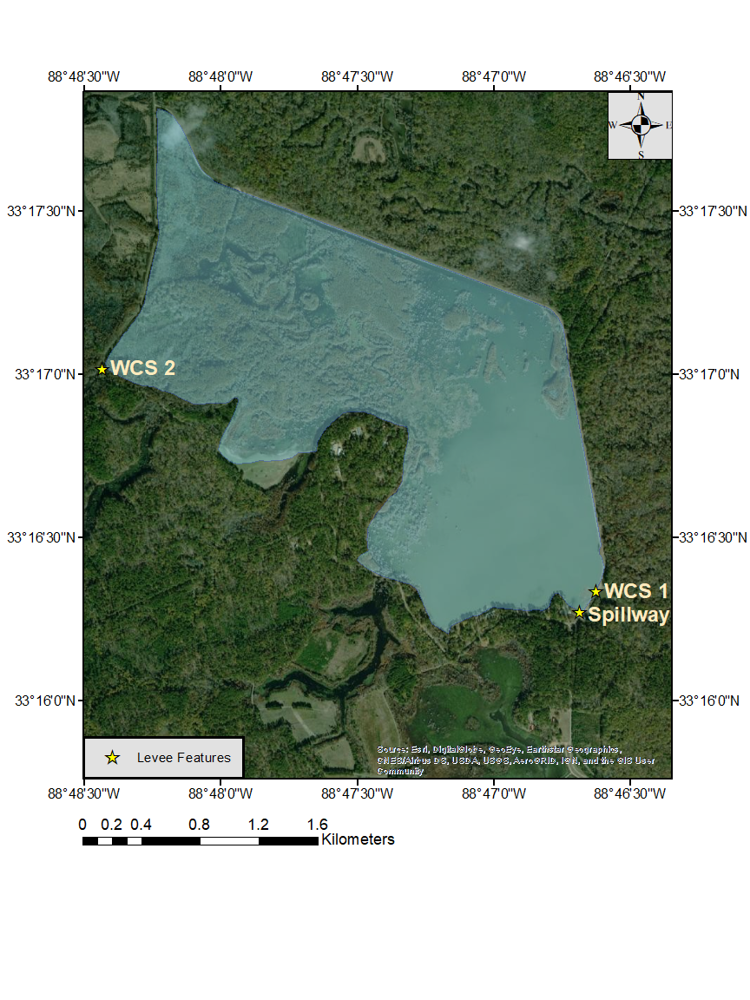

Map of Bluff Lake, Sam D. Hamilton Noxubee National Wildlife Refuge

Bluff Lake, Sam D. Hamilton Noxubee National Wildlife Refuge, Noxubee, Oktibbeha, and Winston Counties, MS, spring 2020. Primary reservoir levees (gold stars) and water control devices (WCS, Spillway) also noted. The blue polygon represents reservoir coverage.

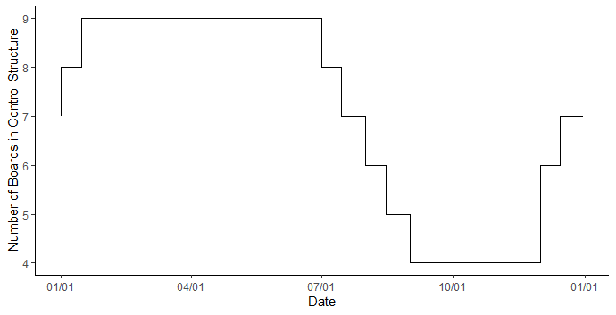

Drawdown schedule by date for Bluff Lake, Sam D. Hamilton Noxubee National Wildlife Refuge

Plot of drawdown schedule by date for Bluff Lake, Sam D. Hamilton Noxubee National Wildlife Refuge, Noxubee, Oktibbeha, and Winston Counties, MS. The y-axis represents the number of stage boards present in water control structure number 1 in the southeastern corner of the reservoir. The height of each stage board measures approximately 18.5-cm. Horizontal lines are indicate drawdown periods.

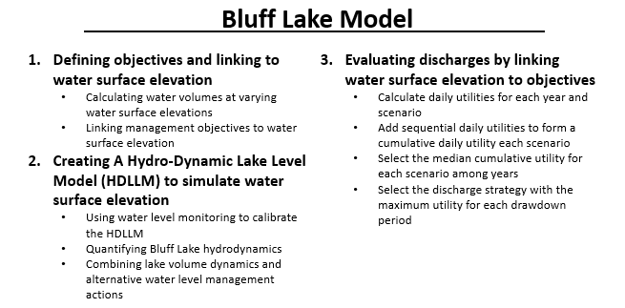

Decision model outline

Outline of a decision model for Bluff Lake, Sam D. Hamilton Noxubee National Wildlife Refuge, Noxubee, Oktibbeha, and Winston Counties, MS describing the steps for analyzing the effects of variable discharge strategies on refuge management objectives, including drawdown period and variable inflow.

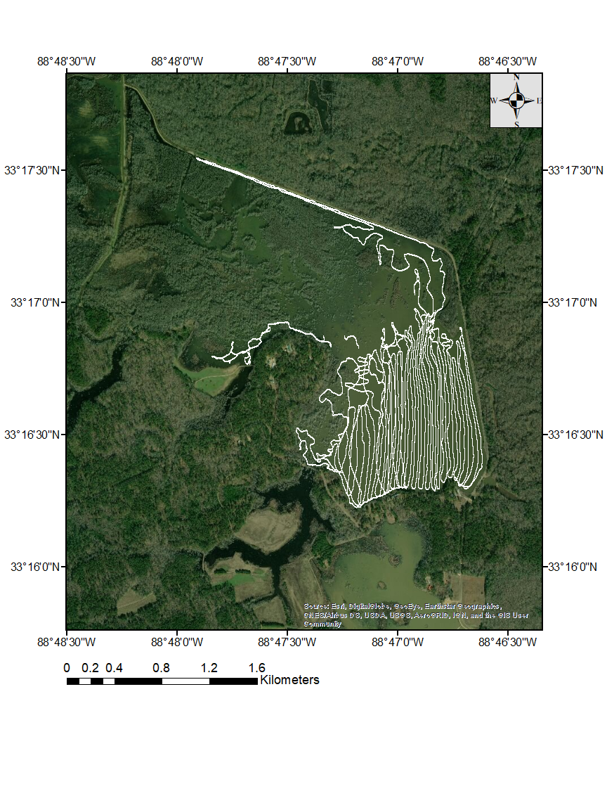

Bathymetric mapping transect map

Map of bathymetric mapping transects completed from January 2019 to February 2020 within Bluff Lake, Sam D. Hamilton Noxubee National Wildlife Refuge, Noxubee, Oktibbeha, and Winston Counties, MS. White lines represent transects of depth data produced with a Humminbird fish finder.

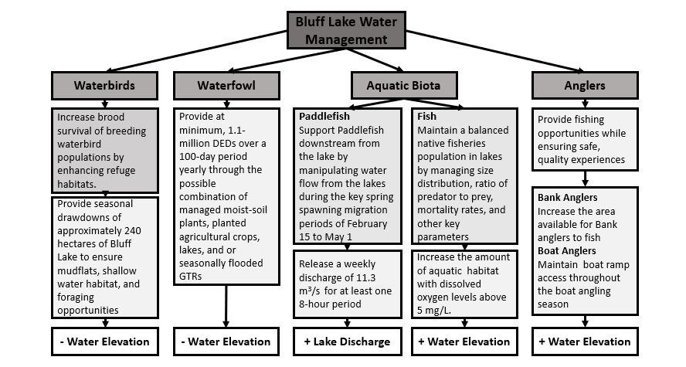

Outline of refuge objectives related to the water level management

Outline of Sam D. Hamilton Noxubee National Wildlife Refuge objectives related to the water level management of Bluff Lake, Sam D. Hamilton Noxubee National Wildlife Refuge, Noxubee, Oktibbeha, and Winston Counties, MS. The figure is structured such that each objective is presented as a stand-alone term, followed by the objective metrics used to measure how each objective is accomplished. Lastly, the means to accomplish objectives via water level management are identified. Mathematical signs on water elevation (bottom rectangles) represent increasing or decreasing the number of stage boards in water control structure number 1. “+ Lake Discharge” represents an increase in reservoir discharge from water control structure number 1.

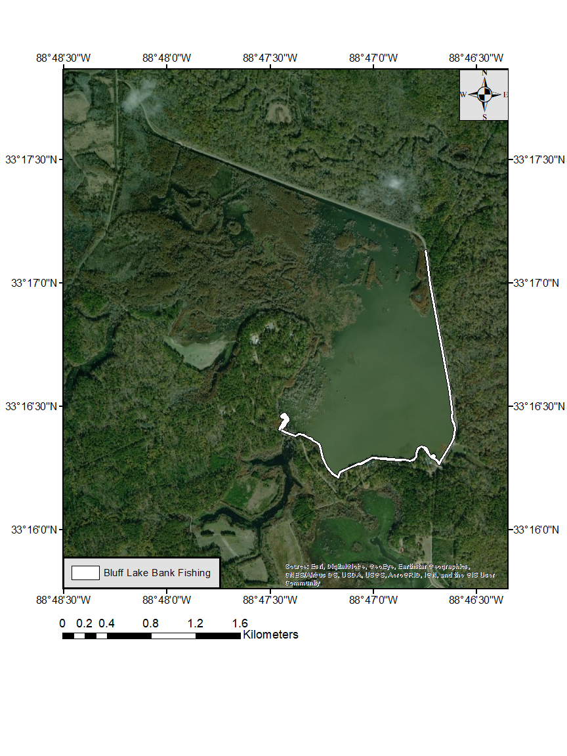

Map of accessible bank areas and boardwalks for fishing

Map of accessible bank areas and boardwalks for fishing within Bluff Lake, Sam D. Hamilton Noxubee National Wildlife Refuge, Noxubee, Oktibbeha, and Winston Counties, MS. Fishable areas appear in white.

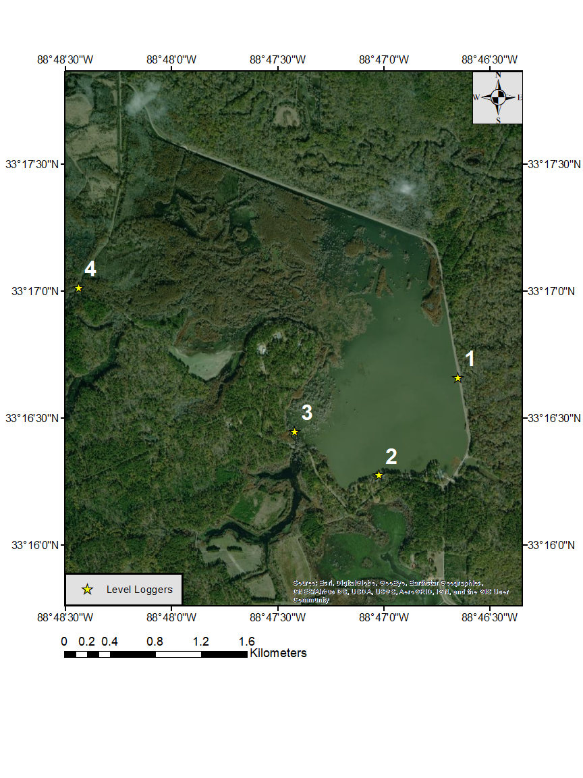

Map of water level logger deployment locations

Map of water level logger deployment locations along the edges of Bluff Lake, Sam D. Hamilton Noxubee National Wildlife Refuge, Noxubee, Oktibbeha, and Winston Counties, MS, spring 2020.Hobo level loggers are represented by gold stars. Loggers 1 and 3 recorded lake water surface elevation. Logger 4 recorded the stage of the Noxubee River outside the levee boundary of Bluff Lake. Logger 2 recorded barometric pressure.

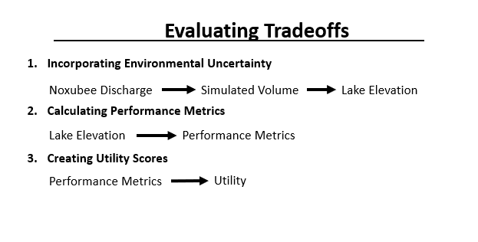

Conceptual diagram of utility calculations

Conceptual diagram of how utilities were calculated for alternate discharge strategies. These utilities could then be compared to select the best strategy.

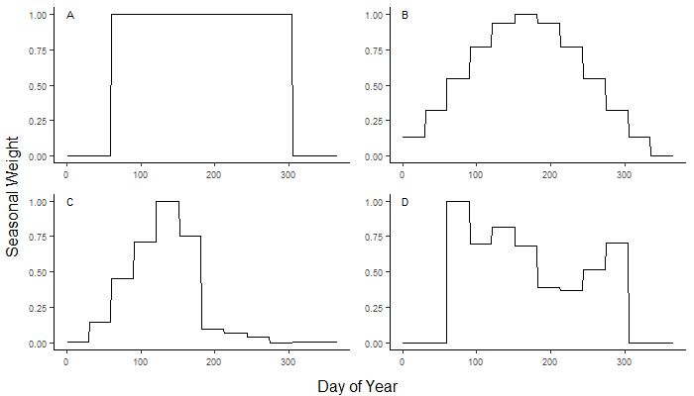

Plots of seasonal weighting applied to refuge objective metrics.

(A) Plot of the proportional seasonal weight assigned to waterfowl objective performance metrics by Julian day of year. (B) Plot of the proportional seasonal weight assigned to waterbird objective performance metrics by Julian day of year. (C) Plot of the proportional seasonal weight assigned to the bank angler component of the fishery objective by Julian day of year. (D) Plot of the proportional seasonal weight assigned to the boating angler component of the fishery objective by Julian day of year.

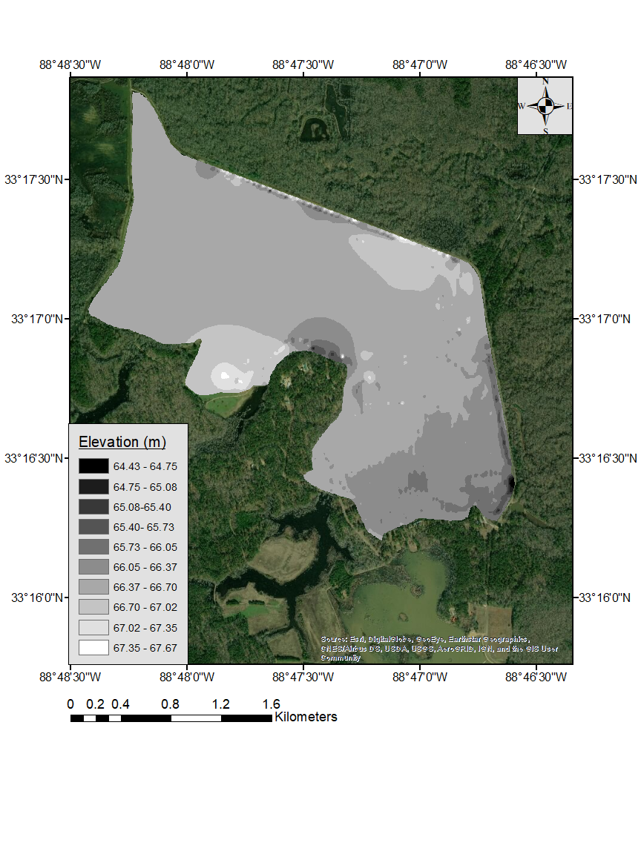

Lakebed elevation map

Map of lakebed elevation for Bluff Lake, Sam D. Hamilton Noxubee National Wildlife Refuge, Noxubee, Oktibbeha, and Winston Counties, MS. Supporting data collected from 2019 to 2020. Colors denote change in elevation. The elevation map was created using the spline tool in ArcMap (version 10.7.1).

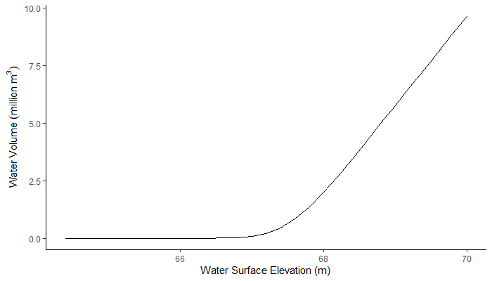

Water surface elevation and water volume relationship

Line plot of the relationship between water surface elevation and water volume for Bluff Lake, Sam D. Hamilton Noxubee National Wildlife Refuge, Noxubee, Oktibbeha, and Winston Counties, MS.

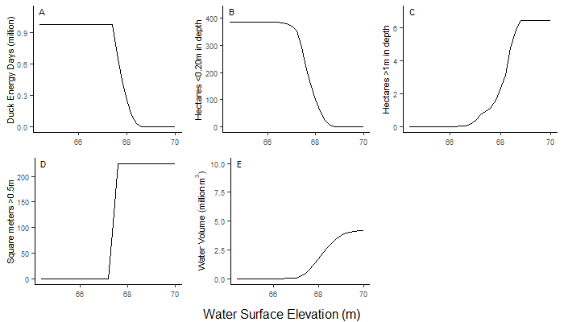

Plots of calculated objective metrics assigned to each objective.

(A) Line plot of the predicted DEDs produced by moist soil plants in exposed areas of Bluff Lake, Sam D. Hamilton Noxubee National Wildlife Refuge, Noxubee, Oktibbeha, and Winston Counties, MS by water surface elevation. Data points represent the number of exposed hectares multiplied by the predicted yield of DEDs per hectare. (B) Line plot of the predicted number of hectares of waterbird habitat. Hectares < 20-cm in depth at each elevation were considered as waterfowl habitat. (C) Line plot of the wetted ramp area available for launching boats. Boating access was represented as the area of the boat ramp >0.5-m in depth. (D) Line plot of the number of hectares available for bank fishing. Shoreline (bank fishing) waters > 1-m in depth that were within 75 yards of bank fishing areas were considered. (E) Line plot of the volume of Bluff Lake, MS in cubic meters > 5-mg/L dissolved oxygen by elevation.

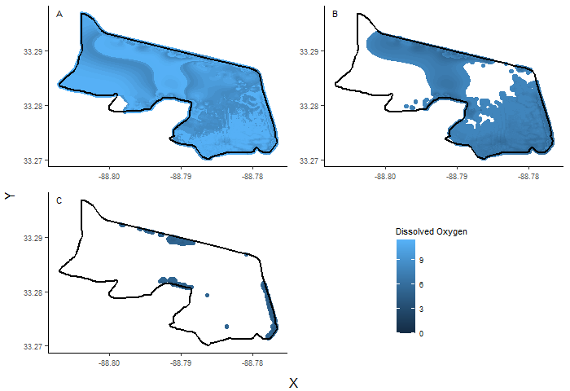

Spatial plot of dawn dissolved oxygen (DO) modeled within a vertical profile

Spatial plot of dawn dissolved oxygen (DO) modeled within (A) the first 1 meter of the depth profile, (B) 1 to 2 meter depths, and (C) > 2-m. DO for this example was modeled under a scenario beginning with a DO level of 10-mg/L and a temperature of 25 °C at dusk. Water surface elevation for the example model was 68.4-m above sea level, which corresponds to 9 stage boards in water control structure number 1 or the starting elevation of drawdown period 2. Color gradient in the plot represents DO levels. The black border represents the levee border of Bluff Lake, Sam D. Hamilton Noxubee National Wildlife Refuge, Noxubee, Oktibbeha, and Winston Counties, MS.

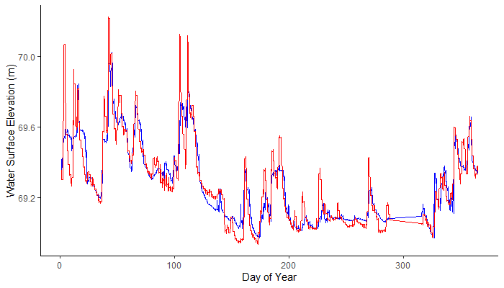

Predicted water surface elevation at lake inflow by Julian day of year

Line plot of actual and predicted water surface elevation by day of year on the Noxubee River side of WCS 2 on Bluff Lake, Sam D. Hamilton Noxubee National Wildlife Refuge, Noxubee, Oktibbeha, and Winston Counties, MS. The blue line represents the water surface elevation recorded by a HOBO level logger. The red line represents the fit of a generalized additive model used to predict elevation at that logger given discharge for the Noxubee River near Macon, MS (02448000; R2 adj.=0.854).

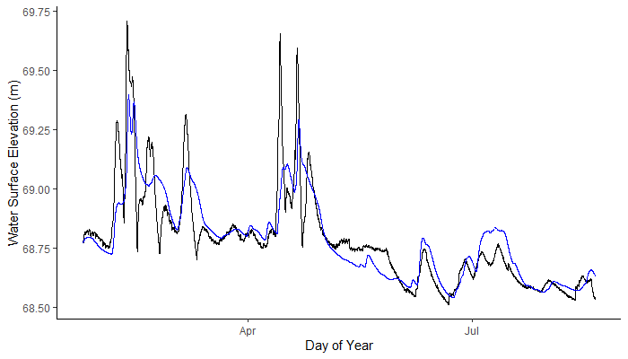

Modeled water surface elevation of Bluff Lake by Julian day of year

Modeled water surface elevation of Bluff Lake, Sam D. Hamilton Noxubee National Wildlife Refuge, Noxubee, Oktibbeha, and Winston Counties, MS by Julian day of year. Line plot of water surface elevation for Bluff Lake, Sam D. Hamilton Noxubee National Wildlife Refuge, Noxubee, Oktibbeha, and Winston Counties, MS by Julian day of year. The black line represents average water surface elevation collected from water level loggers within the reservoir. The blue line represents water surface elevation modeled by estimated inflow and outflow from 2019 to 2020 (R2=0.72).

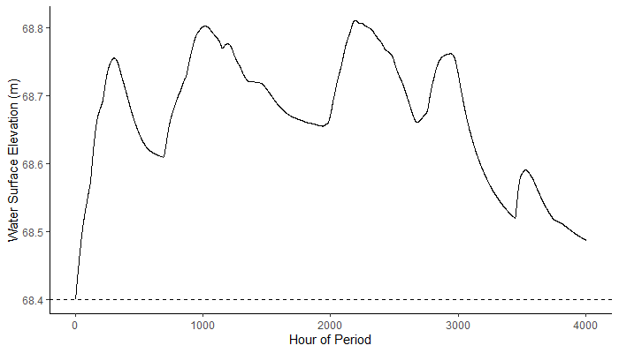

Line plot of modeled water surface elevation of Bluff Lake by hour

Line plot of modeled water surface elevation for Bluff Lake, Sam D. Hamilton Noxubee National Wildlife Refuge, Noxubee, Oktibbeha, and Winston Counties, MS by hour for drawdown period 2 of an example year, 2019. Elevation modeling began at 68.4-m above sea level, which corresponds to nine stage boards in water control structure number 1. The starting elevation in denoted by the dashed line. Lake inflow and outflow was modeled from Noxubee River discharge (USGS 02448000).

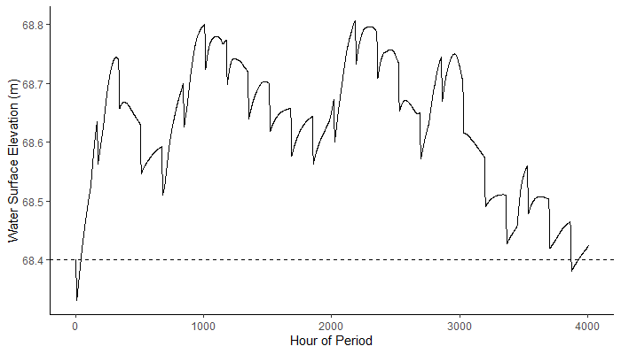

Line plot of modeled lake volume for Bluff Lake by hour with additional 8-hour discharges

Line plot of lake volume of Bluff Lake, Sam D. Hamilton Noxubee National Wildlife Refuge, Noxubee, Oktibbeha, and Winston Counties, MS for period 2 of example year 2019. Discharges of 11.3-m3/s were subtracted hourly over an eight-hour period each week. Lake inflow and outflow was modeled from Noxubee River discharge (USGS 02448000). Elevation modeling began at 68.4-m above sea level, which corresponds to 9 stage boards in the water control structure or the starting elevation of drawdown period 2. The starting elevation in denoted by the dashed line.

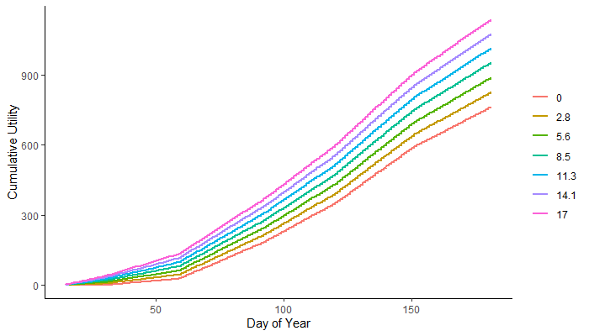

Cumulative daily utilities by Julian day of year

Line plot of cumulative daily utilities for period 2 of example year 2019. Color represents the additional discharge strategy implemented.

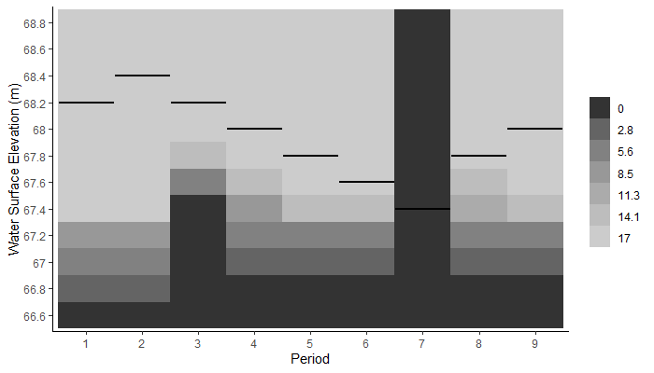

Optimal discharge strategies by drawdown period with drawdown implementation

A heat map representing the optimal discharge strategy for each period of the drawdown cycle followed by Bluff Lake, Sam D. Hamilton Noxubee National Wildlife Refuge, Noxubee, Oktibbeha, and Winston Counties, MS given starting water surface elevation. Black horizontal lines represent the elevation of the water control structure stage boards for each period. The y-axis represents possible water surface elevations above or below the water control structure boards for the beginning of each period. Map shading represents the optimal discharge strategy for each combination of period and starting water surface elevation.

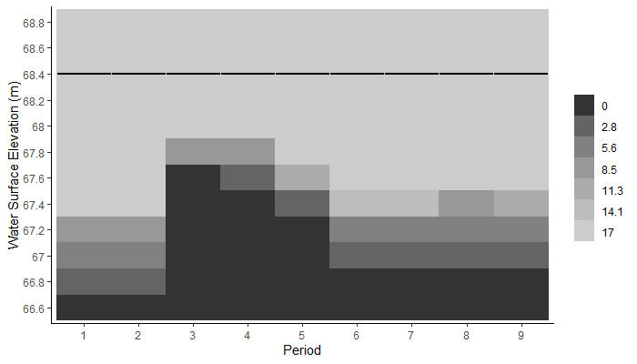

Optimal discharge strategies by drawdown period without water drawdown

A heat map representing the optimal discharge strategy for each period of the drawdown cycle followed by Bluff Lake, Sam D. Hamilton Noxubee National Wildlife Refuge, Noxubee, Oktibbeha, and Winston Counties, MS given starting water surface elevation. This map shows optimal decisions for a year without water level drawdown. Black horizontal lines represent the elevation of the water control structure stage boards at full pool. The y-axis represents possible water surface elevations above or below full pool for the beginning of each period. Map shading represents the optimal discharge strategy for each combination of period and starting water surface elevation.

References

Aboagye, D. and P.J. Allen. 2012. Water quality data associated with Paddlefish habitats on the Noxubee National Wildlife Refuge, Mississippi February to September, 2011. Completion Report to Noxubee NWR.

Aboagye, D.L. and P.J. Allen. 2013. Metabolic and locomotor responses of juvenile Paddlefish *Polyodon spathula* to hypoxia and temperature. Comparative Biochemistry and Physiology. 169. 51-59.

Allen, M.S., S. Sammons, and M.J. Maceina. 2008. Balancing fisheries management and water uses for impounded river systems: an introduction. Pages 1– 3. Edited by: M. S. Allen, S. Sammons, M. J. Maceina. In Balancing fisheries management and water uses for impounded river systems, American Fisheries Society, Symposium 62, Bethesda, Maryland.

Aroviita J., H. Hämäläinen. 2008. The impact of water-level regulation on littoral macroinvertebrate assemblages in boreal lakes. Hydrobiologia 613:45–56.

Checkett, J.M., R.D. Drobney, M. J. Petrie, and D.A. Graber. 2002. True metabolizable energy of moist-soil seeds. Wildlife Society Bulletin 30: 1113–1119.

Connell, J.H. 1978. Diversity in tropical rain forests and coral reefs. Science, 199, 1302–1310.

Conroy, M.J. and J.T. Peterson. 2013. Decision Making in Natural Resource Management: A Structured, Adaptive Approach. Wiley-Blackwell.

Conroy M.J., Peterson J.T. 2009. Integrating management, research, and monitoring: balancing the 3-legged stool. Pages 2 - 10 in Cederbaum SB, Faircloth BC, Terhune TM, Thompson JJ, Carroll JP, eds. Gamebird 2006: Quail VI and Perdix XII. 31 May - 4 June 2006. Warnell School of Forestry and Natural Resources, Athens, GA, USA.

Cooke, G.D. 1980. Lake level drawdown as a macrophyte control technique. Water Resource Bulletin. 16:317–322.

Cooke, G.D., E.B. Welch, S.A. Peterson, S.A. Nichols. 2005. Restoration and management of lakes and reservoirs. 3rd Edition. CRC Press Boca Raton, Florida.

Coppola, G., Miranda, L.E., Colvin, M.E., Hatcher, H.R. and Lashley, M.A. 2019. Submergence Responses of Cool‐Season Annual Plants and Potential for Fish Habitat. North American Journal of Fisheries Management, 39: 1269-1276.

Daugherty, D.J., D.L. Buckmeier, and P.K. Kokkanti. 2011. Sensitivity of Recreational Access to Reservoir Water Level Variation: An Approach to Identify Future Access Needs in Reservoirs, North American Journal of Fisheries Management, 31:1, 63-69.

Duffy, W.G., and D.J. LaBar. 1994. Aquatic invertebrate production in southeastern USA wetlands during winter and spring. Wetlands 14:88-97.

Engineering ToolBox, (2004). Weirs - Open Channel Flow Rate Measurement. [online] Available at: https://www.engineeringtoolbox.com/weirs-flow-rate-d_592.html [11 1. 2020].

EPA. 1986. Quality Criteria for Water: 1986. USEPA, Office of Water Regulations and Standards, Washington, D.C.

Fox, J., P.L Brezonick, M.A. Keirn. 1977. Lake drawdown as a method for improving water quality. U.S. Environmental Protection Agency. Corvallis Environmental Research Laboratory, Corvallis.

Fredrickson, L.H., and T.S. Taylor. 1982. Management of seasonally flooded impoundments for wildlife. U.S. Fish and Wildlife Service Resource Publication 148. 29 pp.

Gilliland, C.R. 2018. Evaluating population dynamics, movement, and spawning success of Paddlefish *Polyodon spathula* at Sam D. Hamilton Noxubee National Wildlife Refuge. Master’s thesis, Mississippi State University, Mississippi State, MS.

Graf, W.L. 1999. Dam nation: a geographic census of large American dams and their hydrologic impacts. Water Resources Research, 35. 1305-1311

Graf, W.L. 2003. Dam Removal Research: Status and Prospects, Heinz Center for Science, Economics and the Environment, Washington, DC. 151.

Hammond, J.S., R.L. Keeney, and H. Raiffa. 1999. Smart choices: a practical guide to making better life decisions. Broadway Books. New York. ISBN: 978-0767908863

Hanson, T.R., L.U. Hatch, and K.C. Clonts, 2002 Reservoir water level impacts on recreation, property, and nonuser values, Journal of the American Water Resources Association, 38, Pages 1007– 1018.

Hellsten, S. K. 1997. Environmental factors related to water level regulation—a comparative study in northern Finland. Boreal Environ. Res. 2:345–367.

Heman, L. M., R.S. Campbell, and L.C. Redmond.1969. Manipulation of Fish Populations Through Reservoir Drawdown. Transactions of the American Fisheries Society, 98(2), 293–304.

Heitmeyer, M. E. 2010. A manual for calculating duck-use-days to determine habitat resource values and waterfowl population energetic requirements in the Mississippi Alluvial Valley. Greenbrier Wetland Services Report 10-01. Blue Heron Conservation Design and Printing LLC, Bloomfield, MO.

Hutt, C.P., K.M. Hunt, S.F. Steffen, S.C. Grado, and L.E. Miranda. 2013. Economic Values and Regional Economic Impacts of Recreational Fisheries in Mississippi Reservoirs. North American Journal of Fisheries Management, 33: 44-55.

Jakus, P.M., P. Dowell, and M.N. Murray. 2000. The effect of ﬂuctuating water levels on reservoir ﬁshing. Journal of Agricultural and Resource Economics 25:520–532.

Jensen, B., and C. Roehm. 2017. AOS Protocol and Procedure: Bathymetry and Morphology of Lakes and Non-Wadable Streams. National Ecological Observatory Network, Boulder, Colorado.

Junk, W.J., P. Bayley, and R. Sparks. (1989). The Flood Pulse Concept in River-Floodplain Systems. Canadian Special Publication of Fisheries and Aquatic Sciences. 106. 110-127.

Kaminski, R.M., J.B. Davis, H.W. Essig, P.D. Gerard, and K.J. Reinecke. 2003. True metabolizable energy of Wood Ducks from acorns compared to other waterfowl foods. Journal of Wildlife Management 67: 542–550.

Kross, J., R.M. Kaminski, K.J. Reinecke, E.J. Penny and A.T. Pearse. 2008. Moist-soil seed abundance in managed wetlands in the Mississippi Alluvial Valley. Journal of Wildlife Management 72:707-714.

Macdonald, J.S., J. Morrison, and D.A. Patterson. 2012. The Efficacy of Reservoir Flow Regulation for Cooling Migration Temperature for Sockeye Salmon in the Nechako River Watershed of British Columbia. North American Journal of Fisheries Management, 32: 415-427.

Magnoni, L.J., E. Eding, I. Leguen, P. Prunet, I. Geurden, R.O.A. Ozorio, J.W. Schrama. 2018. Hypoxia, but not an electrolyte-imbalanced diet, reduces feed intake, growth, and oxygen consumption in rainbow trout (Oncorhynchus mykiss). Scientific Reports 8, 4965.

Marcek, B.J., E.A Burbacher., K. Dabrowski, K.P. Winslow, and S.A. Ludsin. 2020. Interactive Effects of Hypoxia and Temperature on Consumption, Growth, and Condition of Juvenile Hybrid Striped Bass. Transactions of the American Fisheries Society, 149: 71-83.

Marescot, L., G. Chapron, I. Chadès, P.L. Fackler, C. Duchamp, E. Marboutin, and O. Gimenez. 2013. Complex decisions made simple: A primer on stochastic dynamic programming. Methods in Ecology and Evolution 4:872-884.

Meehl, G., A. Tebaldi, and C. Tebaldi. 2004. More intense, more frequent, and longer lasting heat waves in the 21st century. Science. Washington, D.C., 305, Pages 994-997.

Miranda, L.E., M.P. Driscoll, S. Raborn, M.S. Allen, and J. Hargreaves. 1999. Effects of Lake Level on Fish Environment at Eagle Lake. Completion Report to Mississippi Department of Wildlife Fisheries and Parks. Jackson, MS.

Miranda, L.E., J.A. Hargreaves, and S.W. Raborn. 2001. Predicting and managing risk of unsuitable dissolved oxygen in a eutrophic lake. Hydrobiologia 457: 177–185.

Nichols. J.D., M.D. Koneff, P.J. Heglund, M.G. Knutson, M.E. Seamans, J.E. Lyons, J.M. Morton, M.T. Jones, G.S. Boomer, and B.K. Williams. 2011. Climate change, uncertainty, and natural resource management. Journal of Wildlife Management. 75:6–18.

Nicol, S., B. Griffith, J. Austin, C. Hunter. 2014. Optimal water depth management on river-fed National Wildlife Refuges in a changing climate. Climate Change. 124. 271-284.

O’Keefe, D.M. 2006. Conservation and management of Paddlefish in Mississippi with emphasis on the Tennessee-Tombigbee Waterway. Ph.D. Dissertation. Mississippi State University, Starkville, MS.

Paukert, C.P., and W.L. Fisher. 2001. Spring movements of Paddlefish in a prairie

reservoir system. Journal of Freshwater Ecology. 16:113-124.

R Core Team. 2018. R: A language and environment for statistical computing. R Foundation for Statistical Computing, Vienna, Austria.

Reinecke, K.J., R.M. Kaminski, D.J. Moorhead, J. D. Hodges, and J. R. Nassar. 1989. Mississippi alluvial valley. Pages 203-247 in L.M. Smith, R.L. Pederson, and R.M. Kaminski, editors. Habitat management for migrating and wintering waterfowl in North America. Texas Tech University Press, Lubbock, USA.

Rose, B.P. and M.G. Mesa. 2013. Effects of Summer Drawdown on the Fishes and Larval Chironomids in Beulah Reservoir, Oregon. Northwest Science. 87. 3.

Schneider, C.A., W.S. Rasband, and K.W. Eliceiri, 2012. NIH Image to ImageJ: 25 years of image analysis. Nature methods. 9(7): 671-675

Shields, J.T. 1958. Experimental Control of Carp Reproduction through Water Drawdowns in Fort Randall Reservoir, South Dakota. Transactions of the American Fisheries Society, 87: 23-33.

Stainforth, D.A., T. Aina, C. Christensen, M. Collins, N. Faull, D. J. Frame, J. A. Kettleborough, S. Knight, A. Martin, J. M. Murphy, C. Piani, D. Sexton, L. A. Smith, R. A. Spicer, A. J. Thorpe and M. R. Allen. 2005. Uncertainty in predictions of the climate response to rising levels of greenhouse gases. Nature (London). 433. Pages 403– 406.

Stoffels, R.J., N.R. Bond, S. Nicol. Science to support the management of riverine flows. Freshwater Biol. 2018; 63: 996– 1010.

Tracy, H.J. 1957. Discharge characteristics of broad‐crested weirs. U. S. Geological Survey. Circ., 397, 15 pp.

U.S. Department of the Interior. 2014a. Comprehensive Conservation Plan for Sam D. Hamilton Noxubee National Wildlife Refuge, Oktibbeha, Winston, and Noxubee Counties, Mississippi. Fish and Wildlife Service Southeast Region, Atlanta, GA. Available: https://ecos.fws.gov/ServCat/DownloadFile/106086?Reference=66477

U.S. Department of the Interior. 2014b. Waterfowl Habitat Management and Hunt Plan for Sam D. Hamilton Noxubee National Wildlife Refuge, Oktibbeha, Winston, and Noxubee Counties, Mississippi. Fish and Wildlife Service Southeast Region, Atlanta, GA.



REFUGE OBJECTIVES OBTAINED FROM THE 2014 CONSERVATION PLAN FOR   
SAM D. HAMILTON NOXUBEE NATIONAL WILDLIFE REFUGE

The material within the following outline was obtained from the 2014 Comprehensive Conservation Plan for Sam D. Hamilton Noxubee National Wildlife Refuge (Adapted from U.S. Department of the Interior 2014a). The goals, objectives, and strategies include only those with information relevant to the scope of this project. These selected criteria maintain their original phrasing and hierarchical placement.

Goal A: Fish and Wildlife Populations

Manage and protect migratory and native wildlife populations on Sam D. Hamilton Noxubee NWR to contribute to the purposes for which the refuge was established as well as to fulfill the mission of the National Wildlife Refuge System (701 FW 1, USFWS 1992).

Sub-Goal A.1 - Waterfowl

* Manage and protect waterfowl populations in concert with the goals and objectives of North American Waterfowl Management Plan (NAWMP).
  + Objective A.1.1: Provide at minimum, 1.1 million DEDs over a 110-day period yearly through the possible combination of managed moist-soil plants, planted agricultural crops, lakes, and or seasonally flooded GTRs.

Sub-Goal A.2 - Waterbirds

* Manage and protect waterbird populations in concert with the goals and objectives of the North American Waterbird Conservation Plan (USFWS 2007).
  + Objective A.2.3: Increase brood survival of breeding waterbird populations by enhancing refuge habitats
    - Strategy A.2.3.1: Provide seasonal drawdowns of approximately 243 hectares of Bluff Lake to ensure mudflats and shallow water habitats and increase foraging opportunities.

Sub-Goal A.7 - Aquatic Biota

* Manage and protect a diverse assemblage of native fish species, particularly those priority conservation actions identified for the Tombigbee Drainage within Mississippi’s Comprehensive Wildlife Conservation Strategy (710 FW 1, USFWS 2006).
* Objective A.7.2: When not in conflict with waterfowl and threatened and endangered species management, maintain a balanced native fisheries population in lakes by managing size distribution, ratio of predator to prey, mortality rates, and other key parameters.
  + Strategy A.7.2.1: Monitor water levels using permanently fixed water level gauges.
  + Strategy A.7.2.2: Use geographic information systems to record and assess water level measures.
  + Strategy A.7.2.3: Periodically conduct fisheries monitoring.
  + Strategy A.7.2.4: Create deep-water habitats within Bluff Lake and use soil from excavations to create forested islands to serve as possible future rookeries for birds.
  + Strategy A.7.2.5: Use public use regulations as a tool in managing fish populations (i.e., slot or creel limits).
* Objective A.7.3: Support existing populations of Paddlefish by manipulating water flow from the lakes during the key spring spawning migration periods of February 15 to May 1.
  + Strategy A.7.3.1: Weekly release at least an estimated 400 cubic feet per second of water for at least one, 8-hour period using the Bluff Lake radial arm water control structure to increase water flow in areas down stream of structure.

Goal D. Visitor Services

Provide opportunities for compatible wildlife-dependent public uses that promote an understanding and appreciation of fish, wildlife, habitat conservation, and the mission of the National Wildlife Refuge System (605 FW 2, USFWS 2006).

Sub-Goal D.2 - Fishing

* Provide fishing opportunities while ensuring safe, compatible, and quality experiences (605 FW 3, USFWS 2006).

[Adapted from U.S. Department of the Interior 2014a]



ADDITIONAL FISHERY INFORMATION

Fish were collected from Bluff Lake, MS from 2019-2020 using a variety of sampling methods including fyke nets, minnow traps, trotlines, hoop nets, experimental gillnets, and shoreline seining (Table B.1). Additional species were confirmed from of photographs collected by technicians during creel interviews.

Tables

Family, scientific name, common name for fish collected from Bluff Lake, MS from 2019-2020.

|  |  |  |
| --- | --- | --- |
| Family | Scientific name | Common name |
| Amiidae | *Amia calva* | Bowfin |
| Lepisosteidae | *Lepisosteus oculatus* | Spotted Gar |
|  | *Lepisosteus osseus* | Longnose Gar |
|  | *Lepisosteus platostomus* | Shortnose Gar |
| Clupeidae | *Alosa chrysochloris* | Skipjack Herring |
|  | *Dorosoma cepedianum* | Gizzard Shad |
|  | *Dorosoma petenense* | Threadfin Shad |
| Cyprinidae | *Cyprinus carpio* | Common Carp* |
|  | *Hybognathus hayi* | Cypress Minnow |
|  | *Luxilus chrysocephalus* | Striped Shiner |
|  | *Notropis texanus* | Weed Shiner |
|  | *Notemigonus crysoleucas* | Golden Shiner |
| Catostomidae | *Erimyzon sucetta* | Lake Chubsucker |
|  | *Ictiobus bubalus* | Smallmouth Buffalo |
|  | *Minytrema melanops* | Spotted Sucker |
|  | *Moxostoma carinatum* | River Redhorse |
|  | *Moxostoma erythrurum* | Golden Redhorse |
|  | *Moxostoma poecilurum* | Blacktail Redhorse |
| Ictaluridae | *Ameiurus nebulosus* | Brown Bullhead* |
|  | *Ictalurus punctatus* | Channel Catfish* |
|  | *Pylodictis olivaris* | Flathead Catfish* |
| Esocidae | *Esox americanus* | Grass Pickerel |
| Aphredoderidae | *Aphredoderus sayanus* | Pirate Perch |
| Poeciliidae | *Gambusia affinis* | Western Mosquitofish |
| Atherinopsidae | *Menidia beryllina* | Inland Silverside |
| Sciaenidae | *Aplodinotus grunniens* | Freshwater Drum |
| Centrarchidae | *Centrarchus macropterus* | Flier |
|  | *Lepomis cyanellus* | Green Sunfish* |
|  | *Lepomis gulosus* | Warmouth* |
|  | *Lepomis macrochirus* | Bluegill* |
|  | *Lepomis microlophus* | Redear Sunfish* |
|  | *Micropterus salmoides* | Largemouth Bass* |
|  | *Pomoxis annularis* | White Crappie* |
|  | *Pomoxis nigromaculatus* | Black Crappie* |

Asterisks define species harvested by anglers in that period.



ESTIMATING PARAMETERS FOR THE BLUFF LAKE DISSOLVED OXYGEN MODEL

* 1. Introduction

Quantifiable performance metrics related to the fish assemblage were not assigned within the CCP (Appendix A), however, the plan highlights the importance of managing environmental parameters like water depths and dissolved oxygen (DO). To link the fish assemblage objective to water surface elevation I modeled DO at varying water surface elevations.

I modeled dawn DO for variable water surface elevations using a dusk to dawn DO model developed by Miranda et. al 2001. DO concentration for a given morning (; gm−3) can be modeled as a function of water temperature and DO the previous evening (; gm−3) and the rate of change in DO ($dDO$) over time ($dt$) as

|  |  |
| --- | --- |
| $${DO}_{dawn}={DO}_{dusk}-\int_{dusk}^{dawn}{\frac{dDO}{dt}}dt .$$ | (C.1) |

All model equations are included in Table C.1. Unlike the model used by Miranda et al. (2001), which gives a representation of lake area above or below given DO criteria, I adapted the DO model to evaluate lake volume exceeding a given DO threshold. In the model used by Miranda et al. (2001), $\frac{dDO}{dt}$ is calculated as

|  |  |
| --- | --- |
| $$\frac{dDO}{dt}={DO}_{t}-(SR•z^{-1}+WR+DE•z^{-1})$$ | (C.2) |

where the sediment respiration rate (SR), water respiration rate (WR), diffusive exchange (DE), and depth ($z$) are used to calculate the change in DO from the concentration at a given time (${DO}_{t}$). In this section, I will discuss how Bluff Lake specific estimates of (1) water column respiration (WR), (2) sediment respiration (SR), and (3) $k$ were developed to parameterize this model ( $k$ represents the thickness of the air-water boundary layer used in the calculation of DE).

* 1. Methods
     1. Estimating water column respiration (WR)

Water column respiration (WR) for Bluff Lake was calculated from dark and light bottle experiments (Gaarder and Gran 1927). Strings of four glass bottles were deployed at five locations within the reservoir. Two strings were deployed in open water areas, and the remaining three strings were deployed in areas with moderate aquatic vegetation coverage. The string contained opaque glass bottles spaced approximately one meter apart in a vertical profile, with the first bottle a 0.25-m below the water surface.

All bottles were filled with water from the location in which they were deployed. The bottles were held approximately half a meter under the surface and allowed to fill. The DO was measured within each bottle after filling. The strings of bottles were deployed for 24-hours in a vertical profile, attached to a buoy, and anchored in place. The DO for each bottle was measured again after a 24-hour period. WR for Bluff Lake was then calculated as the average change in DO over the change in time for the darkened bottles.

* + 1. Estimating sediment respiration (SR)

Sediment respiration SR for Bluff Lake was calculated using a regression equation developed by Smith and Fisher (1986) where

|  |  |
| --- | --- |
| $$SR \left(\frac{\frac{mmol}{m^{2}}}{h}\right)=0.287*Temperature\left(°C\right)-2.5$$ | (C.3) |

SR was converted to g m−2 min−1 to use in the DO model. This equation models sediment oxygen uptake as a function of water temperature. This was ideal for the DO model as it allowed SR to fluctuate with the variable dusk water temperatures scenarios.

* + 1. Calibrating the thickness of the air-water boundary ($k$)

For k, Miranda et al. used a fixed value of 0.03-cm (2001). This value represents the thickness of the air-water boundary for wind speeds of 1.5 to 2.5-m/s (Clark et al. 1995). I calibrated this parameter to Bluff Lake by running a parameter optimization for the DO equation using oxygen and temperature data collected from Bluff Lake.

Water quality data used in optimization were collected from 20 random points within Bluff Lake (Figure C.1). At each of these points, DO and temperature were measured at a 60-cm depth using a YSI Pro20 DO and temperature probe (Yellow Springs International, Yellow Springs, Ohio, U.S.A.). Temperature and DO were measured in a 20-cm spaced vertical profile at odd numbered points, ending within 20-cm of the reservoir bottom. Initial measurements of DO and temperature took place within a 3-hour period prior to sunset. A second round of measurements were taken the next day within a 3-hour period following sunrise.

Collected DO, temperature, and depth values at dusk were used as inputs into the DO model along with k values varying from 0 to 0.15. The squared difference of the observed dawn DO values and the predicted dawn DO was calculate for each observation. The sum of the squared differences was use as the loss function to minimize by the R function *optimize* to evaluate values of *k* (R Core Team 2018). The function returned the *k* value which best fit the collected data based on the calculated residual sum of squares.

* + 1. Model Validation

DO was then modeled for sampled point locations using the established values for WR, SR, and $k$. The dusk temperature, depth, and dusk dawn DO used corresponded to the levels measured at sampled points. I then compared modeled and measured DO values for the sampled locations.

* + 1. Model Application

Dawn DO were then modeled across a range of starting temperatures and DO levels at dusk for all points of the bathymetric map of Bluff Lake. Dusk water temperatures ranged from 5 to 30 °C and dusk DO ranged from 5 to 10-mg/L. The volume of water with dawn DO levels > 5-mg/L was calculated for each combination of dusk temperature and DO (See main text for full methods).

* 1. Results
     1. Estimating WR, SR, and $k$

Values for WR, SR, and k were calibrated specifically for application on Bluff Lake. Water column respiration (WR) varied slightly between vegetated and open water areas (Figure C.2). Recorded values for both zones were averaged to find the water respiration coefficient for the reservoir, which was equal to 0.072-g/m3/hr. The sediment respiration (SR) calculated for Bluff Lake increased as a function of dusk water temperature used in the model (Figure C.3). The optimum value for k was 0.06-cm (R2=0.47).

* + 1. Model Validation and Application

The DO model was validated by comparing modeled DO to measured DO across 20 sampled points. The constructed model performs well across a range of depths (Figure C.4). The model also performs well across water temperatures (Figure C.5).

The DO model was then applied to the entirety of the lake for variable starting scenarios. The starting dusk water temperature used in the scenario does not dramatically change resulting dawn DO (Figure C.6). While the dusk DO level clearly alters the resulting dawn DO levels in the modeled scenarios (Figure C.7)

* 1. Discussion

By calibrating WR, SR, and $k$ I was able to make more accurate estimates of dawn DO levels. Due to the sampling necessary for parameter calibration, I was also able to test the model. The modeled dawn DO aligns with measured DO at each point, validating model construction and increasing confidence in my application.

The application of the model to the bathymetric map of Bluff Lake allowed me to interpret the response of dawn DO to variable dusk DO and temperature scenarios. The DO model is not sensitive to water temperature but was sensitive to DO. As temperatures do not drastically alter the volume habitat with DO levels > 5-mg/L, I chose to average resulting lake volumes across temperature and DO scenarios.

Tables

Table of the equations and components used within the dawn dissolved oxygen model developed in Miranda et al. (2001).

|  |  |
| --- | --- |
| **Dawn Dissolved Oxygen Model** | |
| $${DO}_{dawn}={DO}_{dusk}-\int_{dusk}^{dawn}{\frac{dDO}{dt}}dt$$ | |
| Additional Equations | $$\frac{dDO}{dt}={DO}_{t}-(SR•z^{-1}+WR+DE•z^{-1})$$ $SR=((0.287•T-2.5)0.003)/60$ $WR=$ 0.0012 $$DE=\left({DO}_{t}{DO}_{sat}\right)Dk^{-1}•0.6 {DO}_{sat}=1.09+10.5e^{-0.0371T}$$ |
| Definition of Terms | $DO$ =dissolved oxygen t = time (1-minute intervals)  *z* = distance to bottom (m) SR = sediment respiration WR = water respiration DE = diffusive exchange  *T* = water temperature (°C)  *D* = molecular diffusion coefficient $(2.2•{10}^{-5})$ $k=$ thickness of the air-water boundary layer (0.06-cm) ${DO}_{sat}$ = DO concentration (mg/L) at saturation |

Figures

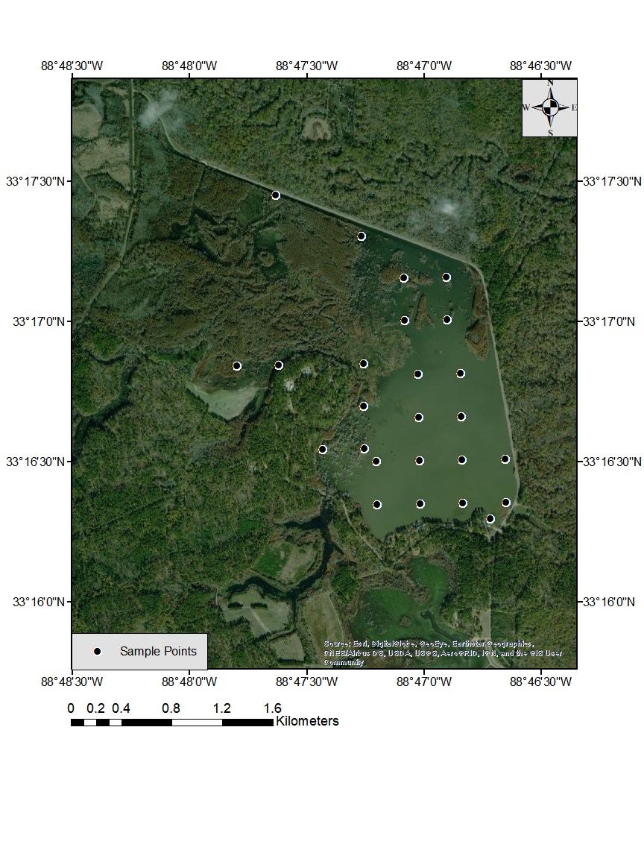

Water quality sampling points

A grid of twenty nonaligned random points was allocated within the sampling area of Bluff Lake, Sam D. Hamilton Noxubee National Wildlife Refuge, Noxubee, Oktibbeha, and Winston Counties, MS. Dissolved oxygen, temperature, and secchi transparency were measured at these points throughout each water quality sampling day.

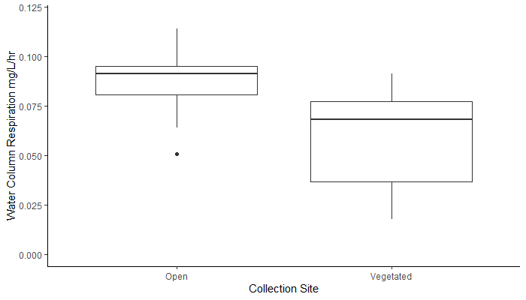

Comparison of water column respiration of vegetated and open water areas

Box plot of water column respiration measured for vegetated and open water areas of Bluff Lake, Sam D. Hamilton Noxubee National Wildlife Refuge, Noxubee, Oktibbeha, and Winston Counties, MS. Vertical bars represent the 10th and 90th percentiles. Circles represent outliers.

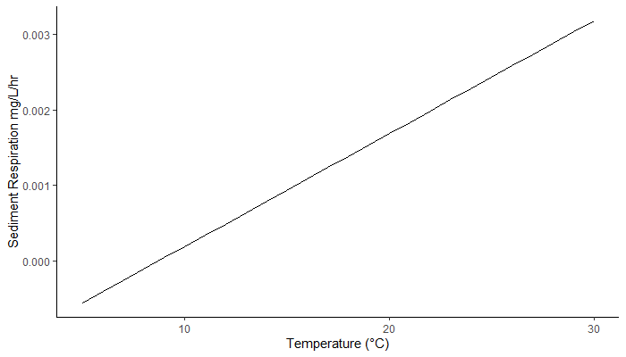

Sediment respiration rates by water temperature

Line plot of the measured sediment respiration of Bluff Lake, Sam D. Hamilton Noxubee National Wildlife Refuge, Noxubee, Oktibbeha, and Winston Counties, MS by the measured water temperature.

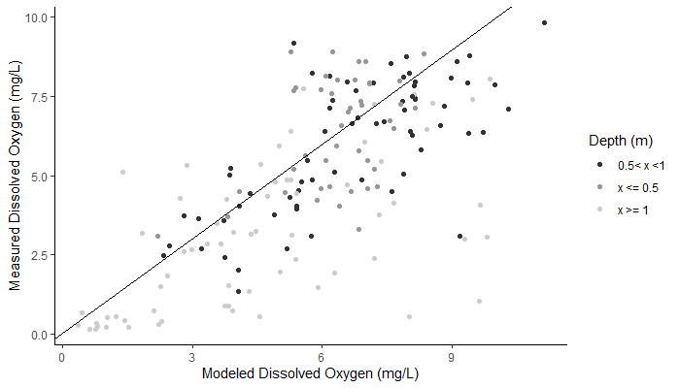

Comparison of true and modeled dissolved oxygen including depth

Scatterplot comparing true dissolved oxygen and modeled dissolved oxygen for Bluff Lake, Sam D. Hamilton Noxubee National Wildlife Refuge, Noxubee, Oktibbeha, and Winston Counties, MS. Color represents the depth of the point at which dissolved oxygen was measured and modeled.

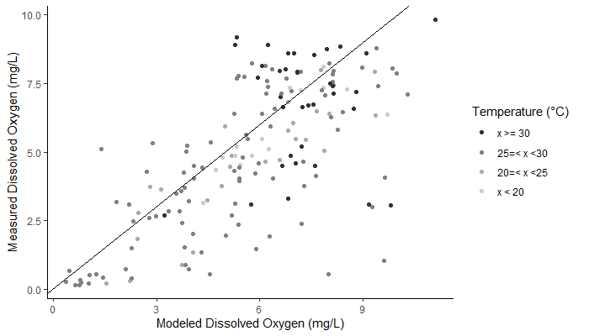

Comparison of true and modeled dissolved oxygen including water temperature

Scatterplot comparing true dissolved oxygen and modeled dissolved oxygen for Bluff Lake, Sam D. Hamilton Noxubee National Wildlife Refuge, Noxubee, Oktibbeha, and Winston Counties, MS. Color represents the temperature measured at the point when dissolved oxygen was measured. This temperature was then used to model dissolved oxygen at that point.

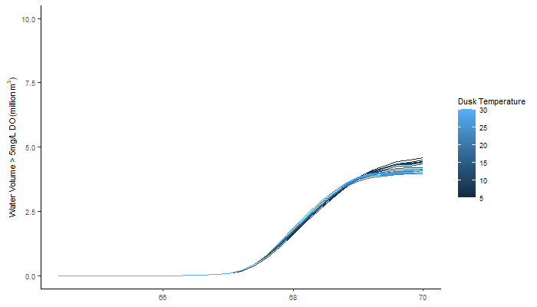

Water volume with dissolved oxygen (DO) concentrations > 5-mg/L modeled at dawn given starting dusk temperature

Line plot of the volume of Bluff Lake, Sam D. Hamilton Noxubee National Wildlife Refuge, Noxubee, Oktibbeha, and Winston Counties, MS with dissolved oxygen (DO) concentrations > 5-mg/L modeled at dawn for each starting dusk temperature. Starting dusk temperatures are represented by line color.

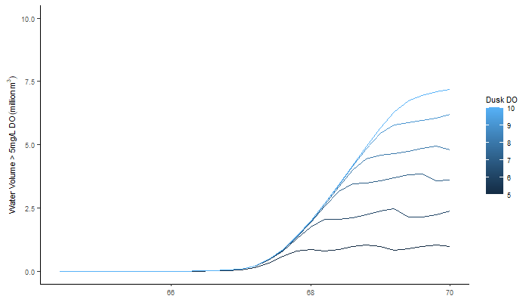

Water volume modeled with dissolved oxygen (DO) concentrations > 5-mg/L at dawn given starting dusk dissolved oxygen

Line plot of the volume of Bluff Lake, Sam D. Hamilton Noxubee National Wildlife Refuge, Noxubee, Oktibbeha, and Winston Counties, MS with dissolved oxygen (DO) concentrations > 5-mg/L modeled at dawn for each starting dusk dissolved oxygen. Starting dusk dissolved oxygen levels are represented by line color.

References

Clark, J. F., P. Schlosser, R. H. Wanninkhof, H. J. Simpson, W. S. F. Schuster & D. T. Ho, 1995. Gas transfer velocities for SF6 and 3He in a small pond at low wind speeds. Geophys. Res. Lett 22: 93–96.

Gaarder, T., and H. H. Gran. 1927. Investigations of the production of plankton in the Oslo Fjord. Rapp. et Proc.-Verb., Cons. Int. Explor. Mer, 42: l-48.

Miranda, L. E., J. A. Hargreaves, and S.W. Raborn. 2001. Predicting and managing risk of unsuitable dissolved oxygen in a eutrophic lake. Hydrobiologia 457: 177–185.

R Core Team. 2018. R: A language and environment for statistical computing. R Foundation for Statistical Computing, Vienna, Austria.

Smith, L. K., and T. R. Fisher. 1986. Nutrient fluxes and sediment oxygen demand associated with the sediment-water interface of two aquatic environments. *In* Sediment oxygen demand. Institute of Natural Resources, University of Georgia, Athens.



ANALYSIS OF HYDROLOGICAL PATTERNS OF THE NOXUBEE RIVER NEAR MACON, MS

* 1. Introduction

Noxubee River discharge directly influences reservoir inflow and the subsequent water surface elevation of Bluff Lake, Mississippi. In turn, water surface elevation drives performance metrics of management objectives and is the deciding factor on which management actions are optimal. The purpose of this analysis was to (1) identify trends in high and low discharge patterns within and among years, (2) describe the seasonality of high and low flow events, and (3) describe patterns in annual frequency and duration of high and low flow events in the context of evaluating if these metrics change predictably over time.

* 1. Methods

Discharge data recorded by USGS gauge 02448000 on the Noxubee River near Macon, MS from 1945 to 2020 were used to analyze hydrologic patterns affecting Bluff Lake. High and low discharges, represented by the 90th and 10th percentiles respectively, were studied to detect any potential changes discharge patterns within and among years. High and low flow days were defined as mean daily discharges above the 90th percentile (92.31-m3/s) and 10th percentile (1.81-m3/s) for the period of record from 1945 to 2020.

* 1. Results
     1. Identify trends in high and low discharge patterns within and among years
* The 90th percentile of flows showed no pattern of increase or decrease in the timeseries (Figure D.1).
* The cumulative 90th percentile of flows leveled off after a period of 40 years (Figure D.2).
* The 10th percentile of flows shows a pattern of slight increase over the timeseries (Figure D.3).
* The cumulative 10th percentile of flows continues to increase over the timeseries of available data (Figure D.4).
  + 1. Describe the seasonality of high and low flow events
* High flow events are seasonally concentrated between days 50 and 225 of a water year (Figure D.5).
* Low flow events are seasonally concentrated between days 0 to 100 and from days 225 to 365 of a water year (Figure D.6).
  + 1. Describe patterns in the frequency and duration of high and low flow events
* A generalized linear model with a Poisson distribution was fit to predict the number of high flow days per water year. According to this model year is a significant predictor of the number of high flow days (p<0.01; Figure D.7).
* A generalized linear model with a Poisson distribution was fit to predict the number of high flow events per water year. Consecutive days above the 90th percentile were counted as a single event. According to this model year is not a significant predictor of the number of high flow events (p=0.97; Figure D.8).
* The duration of high flow events is highly variable within each year (Figure D.9).
* A generalized linear model with a Poisson distribution was fit to predict the average duration of high flow events per water year. Consecutive days above the 90th percentile were counted as a single event. According to this model, water year is a significant predictor of the duration of high flow events (p<0.05; Figure D.10).
* A generalized linear model with a Poisson distribution was fit to predict the number of low flow days per water year. Low flow days were defined as dates with mean daily discharges below the 10th percentile (1.812-m3/s) for the period of record from 1945 to 2020. According to this model, water year is a significant predictor of the number of low flow days (p<0.001; Figure D.11).
* A generalized linear model with a Poisson distribution was fit to predict the number of low flow events per water year. Consecutive days below the 10th percentile were counted as a single event. According to this model, water year is a significant predictor of the number of low flow days (p<0.001; Figure D.12).
* The duration of low flow events is highly variable within each year (Figure D.13).
* A generalized linear model with a Poisson distribution was fit to predict the average duration of low flow events per water year. Consecutive days below the 10th percentile were counted as a single event. According to this model, water year is not significant predictor of the number of low flow days (p<0.09; Figure D.14).
  1. Discussion

The number of high flow and low flow days are decreasing annually along with the duration of high flow events. However, increases in high flows do not present as ecologically significant. Additionally, the cumulative 10th percentile of low flows has been steadily increasing from 1945 to 2020. The number of these categorically low flow events have been decreasing annually as well. These results suggest that the magnitude and duration of base flows is increasing. However, the frequency and duration of both high and low flow events remains highly variable among years. Multiple years should be considered in the decision analysis to account for uncertainty in lake inflow. However, this analysis shows that base flows are increasing within the Noxubee River watershed, reducing some of the risk around water availability.

Figures

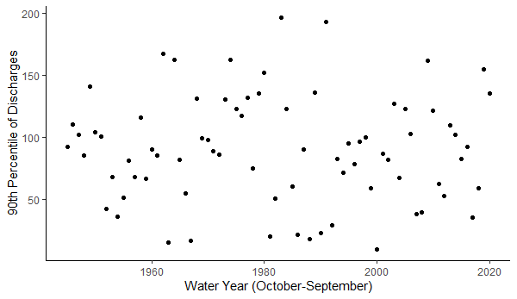

90th percentile break in average daily discharge for each water year

Scatterplot of the 90th percentile break in average daily discharge for each water year (October 1 to September 30). Points represent the discharge value > 90% of all other daily averages for that year. Data were collected from the USGS gauge 02448000 on the Noxubee River near Macon, MS from 1945 to 2020.

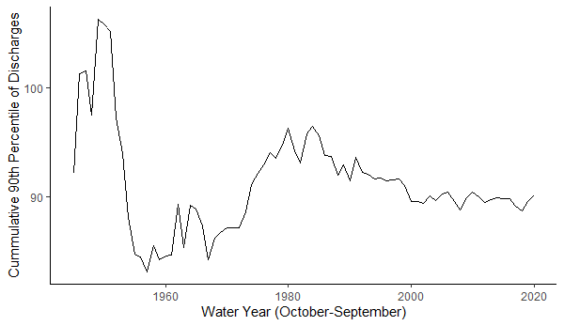

Annual cumulative 90th percentile of daily discharges for each water year

Plot of the annual cumulative 90th percentile of daily discharges for each water year (October 1 to September 30) from 1945 to 2020. Yearly data were sequentially merged and the 90th percentiles were calculated at each interval. Data collected from the USGS gauge 02448000 on the Noxubee River near Macon, MS from 1945 to 2020.

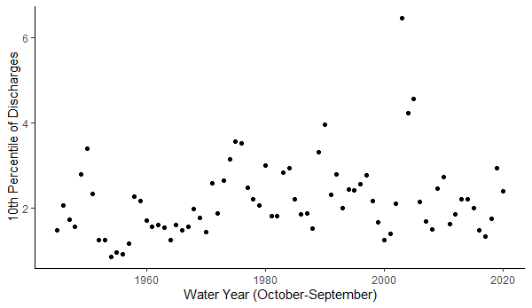

10th percentile of discharge events by water year

Scatterplot of discharge events falling in the 10th percentile for each water year (October 1 to September 30). Points represent the discharge value < 10% of all other daily averages for that year. Data collected from the USGS gauge 02448000 on the Noxubee River near Macon, MS from 1945 to 2020.

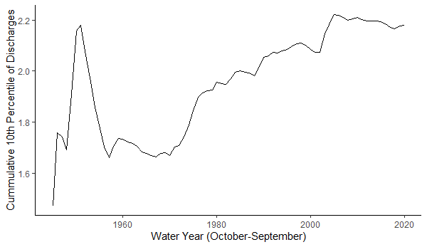

Annual cumulative 10th percentile of discharges by water year

Plot of the annual cumulative 10th percentile of discharges by water year (October 1 to September 30) from 1945 to 2020. Yearly data were sequentially merged, and the 10th percentiles were calculated at each interval. Data collected from the USGS gauge 02448000 on the Noxubee River near Macon, MS from 1945 to 2020.

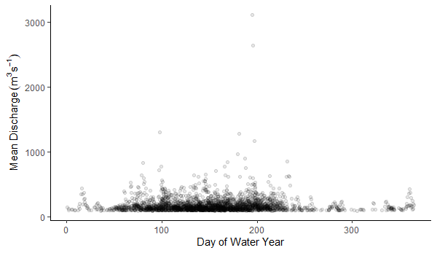

High discharge events from 1945 to 2020 by day of water year

Scatterplot of high discharge events recorded by USGS gauge 02448000 on the Noxubee River near Macon, MS from 1945 to 2020 by day of water year (October 1 to September 30). High discharge days were defined as mean daily discharges above the 90th percentile (92.31-m3/s) for the period of record from 1945 to 2020. Darker areas signify overlapping points.

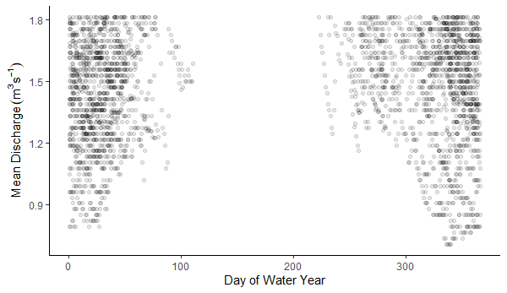

Low discharge events from 1945 to 2020 by day of water year

Scatterplot of low discharges recorded by USGS gauge 02448000 on the Noxubee River near Macon, MS from 1945 to 2020 by day of water year. A water year begins on October 1st and ends September 30th. Low discharge events were defined as mean daily discharges below the 10th percentile (1.81-m3/s) for the period of record from 1945 to 2020. Darker areas signify overlapping points.

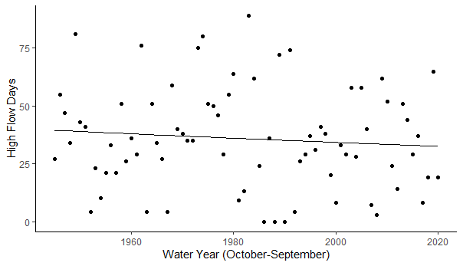

Frequency of high flow days per water year

Relationship between the number of high flow days per water year (October 1 to September 30)

recorded by USGS gauge 02448000 on the Noxubee River near Macon, MS from 1945 to 2020. High flow days were defined as dates with mean daily discharges above the 90th percentile (92.31-m3/s) for the period of record from 1945 to 2020. The solid line represents a generalized linear model fit to the discharge data.

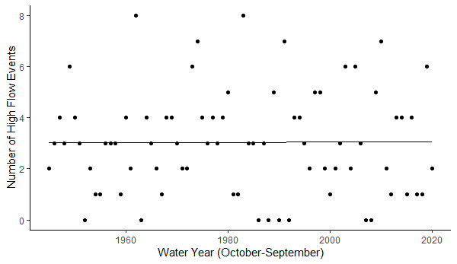

Frequency of high flow events per water year

Relationship between the number of high flow events per water year (October 1 to September 30) recorded by USGS gauge 02448000 on the Noxubee River near Macon, MS from 1945 to 2020. High flows were defined as mean daily discharges above the 90th percentile (92.31-m3/s) for the period of record from 1945 to 2020. Consecutive days above the 90th percentile were counted as a single event. The solid line represents a generalized linear model fit to the discharge data.

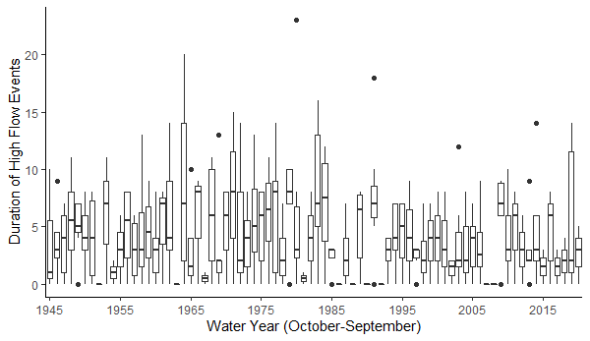

Duration of high flow events by water year

Boxplots representing the duration in consecutive days of high flow events by water year (October 1 to September 30) recorded by USGS gauge 02448000 on the Noxubee River near Macon, MS. High flow days were defined as mean daily discharges above the 90th percentile (92.31-m3/s) for the period of record from 1945 to 2020. Consecutive days above the 90th percentile were counted as a single event. Lower and upper fences are the 25th and 75th percentiles, and the median is in between. Bars represent the 10th and 90th percentiles. Closed circles represent outliers. High flow day were defined as mean daily discharges above the 90th percentile (92.31-m3/s) of all discharges for the period of record from 1945 to 2020.

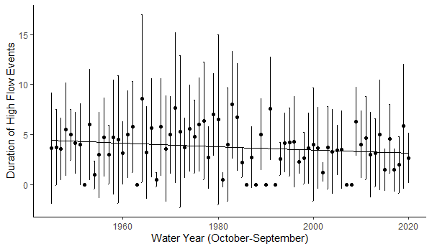

Trends in duration of high flow events by water year

Relationship between the average annual duration in consecutive days of high flow events over time recorded by USGS gauge 02448000 on the Noxubee River near Macon, MS. High flow days were defined as mean daily discharges above the 90th percentile for the period of record from 1945 to 2020. Consecutive days above the 90th percentile were counted as a single event. Points represent the annual average high flow duration in consecutive days. The vertical solid line represents a generalized linear model fit to the discharge data.

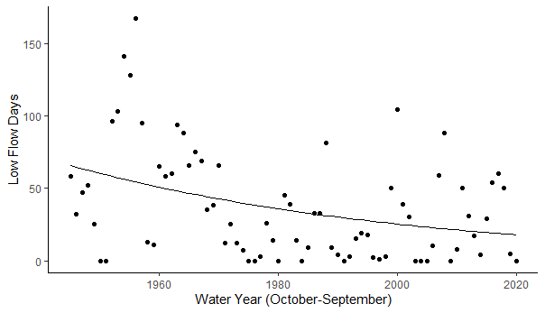

Frequency of low flow days per water year

Scatterplot representing the number of low flow days per water year (October 1 to September 30) recorded by USGS gauge 02448000 on the Noxubee River near Macon, MS from 1945 to 2020. Low flow days were defined as dates with mean daily discharges below the 10th percentile (1.81-m3/s) for the period of record from 1945 to 2020. The solid line represents a generalized linear model fit to the discharge data.

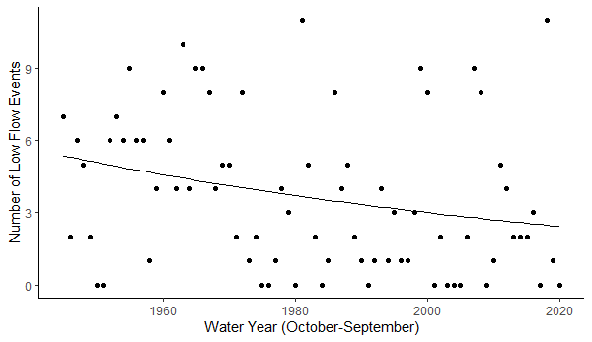

Frequency of low flow events per water year

Scatterplot representing the number of low flow events per water year (October 1 to September 30) recorded by USGS gauge 02448000 on the Noxubee River near Macon, MS from 1945 to 2020. Low flow days were defined as dates with discharges below the 10th percentile (1.81-m3/s) for the period of record from 1945 to 2020. Consecutive days below the 10th percentile were counted as a single event. The solid line represents a generalized linear model fit to the discharge data.

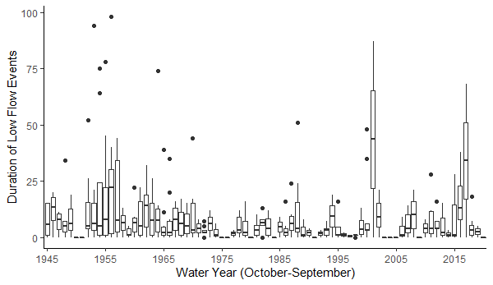

Duration of low flow events by water year

Boxplots representing the duration in consecutive days of low flow events by water year (October 1 to September 30) recorded by USGS gauge 02448000 on the Noxubee River near Macon, MS. Low flow days were defined as dates with discharges below the 10th percentile (1.81-m3/s) for the period of record from 1945 to 2020. Consecutive days below the 10th percentile were counted as a single event. Lower and upper fences are the 25th and 75th percentiles, and the median is in between. Bars represent the 10th and 90th percentiles. Closed circles represent outliers. Low flow events were defined as discharges below the 10th percentile (1.81-m3/s) of all discharges for the period of record from 1945 to 2020.

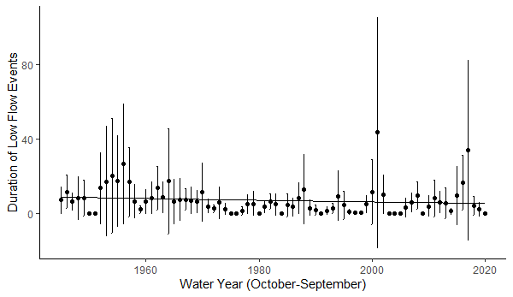

Trends in duration of low flow events by water year

Relationship between the average annual duration in consecutive days of low flow events over time recorded by USGS gauge 02448000 on the Noxubee River near Macon, MS. Low flow dates were defined by mean daily discharges below the 10th percentile (1.81-m3/s) for the period of record from 1945 to 2020. Points represent the annual average high flow duration in consecutive days. The solid line represents a generalized linear model fit to the discharge data.



INSTANTANEOUS COUNTS

* 1. Introduction

To obtain an estimate angler effort, catch per unit of effort (CPUE), and harvest of anglers, roving creel surveys were performed within the open portion of the fishing season (March 1st to October 31st) in 2019 and 2020. Angler counts were used to quantify usage patterns throughout the year. Angler usage patterns were then used to seasonally weight angler objectives. This allows high usage months to have more impact on discharge strategy selection while low use periods have less impact.

* 1. Methods

The roving creel design for this survey was based on the previous surveys completed by Jennings (1985). Each month of the roving creel survey was considered a block. Within each block, dates were categorized as weekday, weekend, with any holidays classified as a weekend. Survey dates were chosen by randomly selecting seven sampling dates per block, three weekdays and four weekends. Each day was separated into “morning” from 6 to 10, “midday” 10 to 2, and “evening” 2 to 6 and “morning” from 7 to 11, “midday” 11 to 3, and “evening” 3 to 7 after daylight savings. During the sampling period, each time category received equal probability of being sampled.

Anglers had three access points, two boardwalks, and limited open shoreline for fishing on Bluff Lake at the study beginning (Figure 2.1). For this design, survey sites included one of the three access points and approximately one-third of the total fishable shoreline (Figure 2.6). For each sampling day the starting site and starting direction were randomly selected. The creel clerk started at the selected site and then moved either clockwise or counterclockwise around the lake. In the initial pass around the lake the clerk conducted an instantaneous count of all anglers. The number of anglers, the groups size, and the fishing method used were also recorded (Figure E.1). The clerk also recorded all vehicles parked on the refuge.

From March 2019-March 2020 the creel clerk also conducted angler interviews. During this time, the clerk finished the initial pass around the lake then reversed direction to conduct interviews (Figure E.2). Anglers were questioned about fish species sought, released, and harvested fish were examined. Fish species were simplified to recognizable groups including, bass, crappie, bream, catfish, or other. Harvested fish were identified to species, then measured for length (nearest mm) and then aggregated to species for weighing (nearest 10 grams).

Angler effort for boating and bank fishing anglers was calculated from instantaneous counts using the ratio of means (ROM) estimator (Pollock et al. 1997; Hoenig et al 1997). Total angling effort for bank and boat anglers ($\hat{E}$) was estimated as

|  |  |
| --- | --- |
| $$\hat{E}=T_{i}I_{j}$$ | (E.1) |

where $T_{i}$ is the total number of hours in the strata of the fishing day and $I_{j}$ is the mean angler count for that strata. Variance for effort was calculated using the variance equation (Pollock et al. 1997; Hoenig et al 1997).

|  |  |
| --- | --- |
| $$Var\left(\hat{E}\right)= \frac{\sum_{i=1}^{n}{{(x_{i}-μ)}^{2}}}{n-1}$$ | (E.2) |

Estimates of catch rate were calculated using the ROM estimator ($\hat{R}$)

|  |  |
| --- | --- |
| $$\hat{R}=\frac{\sum_{j=1}^{n}{C_{j}/n}}{\sum_{j=1}^{n}{L_{j}}/n}$$ | (E.3) |

where $C_{j}$ represents the incomplete catch for the *j*th angler and $L_{j}$ is the incomplete trip length for the *j*th angler. Variance for catch rate estimates were calculated as

|  |  |
| --- | --- |
| $$Var(\hat{R})=\frac{\sum{R^{2}-{(\left(\sum{R}\right)}^{2}}/k)}{k×(k-1)}$$ | (E.3) |

where $R$ represents the catch rate for each angler and $k$ is equal to the number of anglers. Anglers whose trips were 0.5 h or less were excluded from calculations (Hoenig et al. 1997; Pollock et al. 1997).

During instantaneous counts, boating anglers were difficult to observe from the road. Estimates from these counts would underestimate the total angling effort expended to this group. To improve estimates of daily boating angler effort, the mean annual boating group size for observed groups was multiplied by the number of boat trailers and trucks at each access point during each instantaneous count. This estimated angler count was then used to calculate $I_{j}$ for the equation above.

* 1. Results

A total of 116 creel shifts were completed from March 2019 to March 2020. Interviews were stopped in late March of 2020 to reduce unnecessary contact due to COVID-19. Monthly fishing effort estimates were estimated from instantaneous counts completed during the creel surveys. Estimated effort from boating anglers was greater across all months except June (Figure E.3). However, boat angler effort varied among months leading to large confidence intervals (Figure E.3). Fewer anglers were fishing in warmer summer months from June to September (Figure E.4).

We collected information on angler origin, preference, and catch from angler interviews. All interviewed anglers were Mississippi Residents with the majority commuting from counties surrounding the refuge (Figure E.5). Most of these anglers were targeting Crappie and Bream (Figure E.6). However, when the relative frequencies of catch for each species were separated by month, more anglers were fishing for crappie in the spring, but quickly transitioned to angling for bream or had no preference (Figure E.7). Most anglers caught bream, followed by a combination of Black and White Crappie (Figure E.8). The majority of catch in March was comprised of crappie, but from April to August anglers caught more bream (Figure E.9). Catch per unit of effort for crappie both crappie and bream varied seasonally with peaks near key spawning windows (Figure E.10, Figure E.11). Time fished also varied by month (Figure E.12), with the largest ranges in fishing times occurring in March and October.

Figures

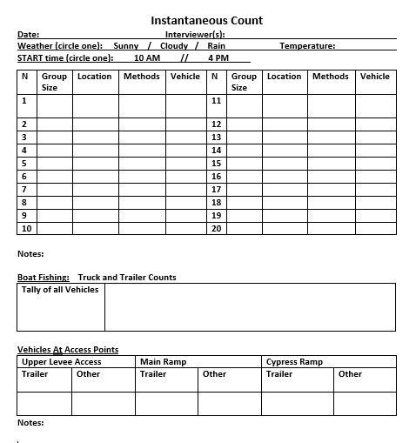

Instantaneous count form

Instantaneous count form used by the creel clerk. While following the driving route and stopping at each boardwalk, clerks recorded the group size, location, and fishing method of anglers that they contact. They also kept a tally of the total number of vehicles that they see on the refuge and record the number of potential boat anglers parked at each access point.

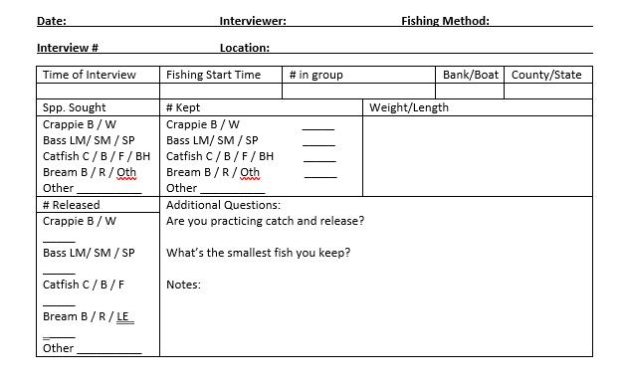

Interview form

Interview form used by the creel clerk. While following the driving route and stopping at each boardwalk, clerks attempted to interview each angler that they contacted. If an angler agreed to an interview, then the creel clerk filled out the form above. The group size, start time, preferred catch, and harvest were recorded. If the angler had fish, then length of each fish was recorded to the nearest millimeter.

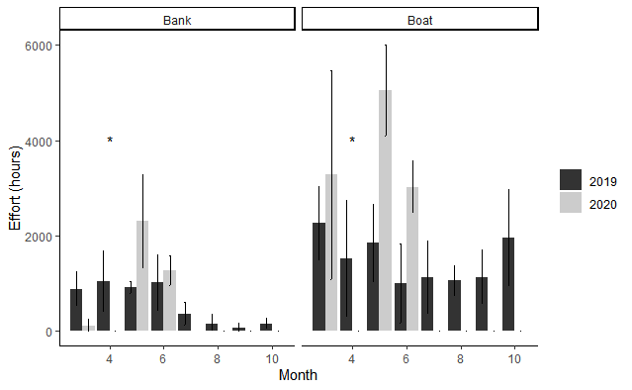

Monthly angling effort estimates by year and angling category

Bar plot of monthly angling effort estimates by year and angling category. Effort for each category was calculated from instantaneous counts of groups, individuals, and boat trailers. Counts took place from March 2019 to May 2020. Lines represent 95% confidence intervals. Colors represents year of data collection. *=no data for 2020

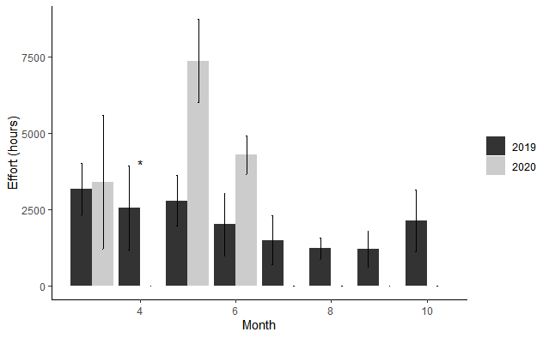

Monthly angling effort estimates by year

Bar plot of monthly angling effort estimates by year. Effort for each category was calculated from instantaneous counts of groups, individuals, and boat trailers. Counts took place from March 2019 to May 2020. Lines represent 95% confidence intervals. Colors represents year of data collection. Asterisks mark missing data for 2020.

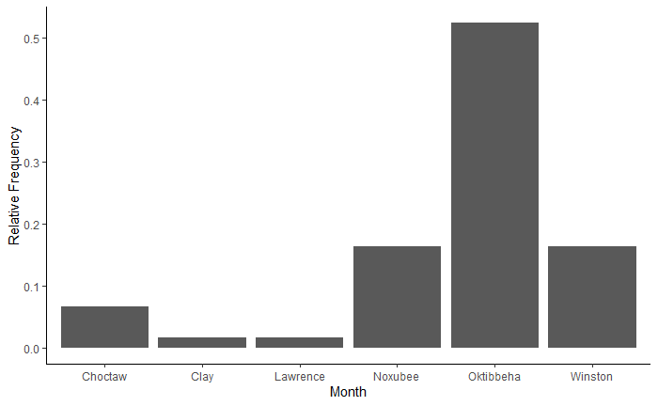

Angler residence

Bar plot of the relative frequency of resident counties reported by anglers interviewed at Bluff Lake, MS from March 2019-May 2020.

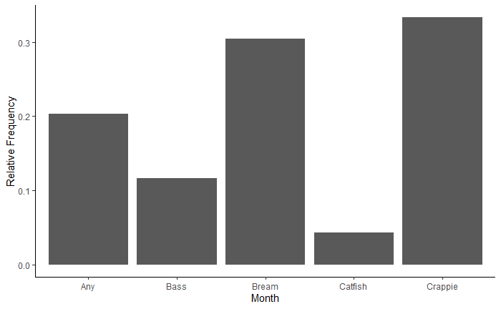

Species sought by anglers

Bar plot of the relative frequency of sought species groups reported by anglers interviewed at Bluff Lake, MS from March 2019-May 2020.

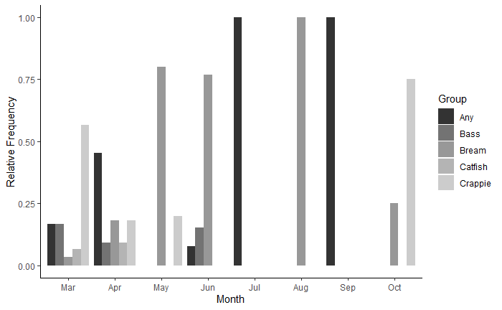

Species caught by month

Bar plot of the relative frequency of fish species caught by anglers separated by month. Interviews took place at Bluff Lake, MS from March 2019-May 2020. Colors denote fish species groups.

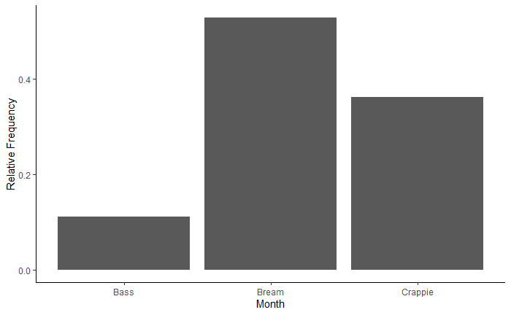 Relative frequency of capture for targeted fish

Bar plot of the relative frequency of fish groups caught by anglers. Interviews took place at Bluff Lake, MS from March 2019-May 2020.

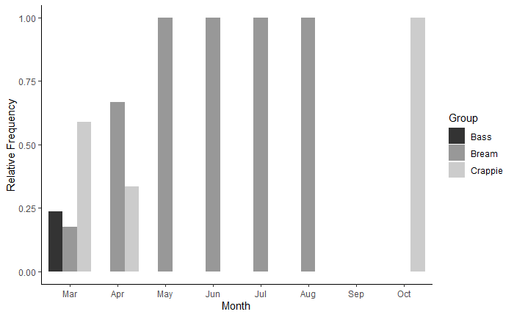 Relative frequency of capture for targeted fish by month

Bar plot of the relative frequency of fish groups caught by anglers separated by month. Interviews took place at Bluff Lake, MS from March 2019-May 2020. No fish were reported in September. Colors denote fish species groups.

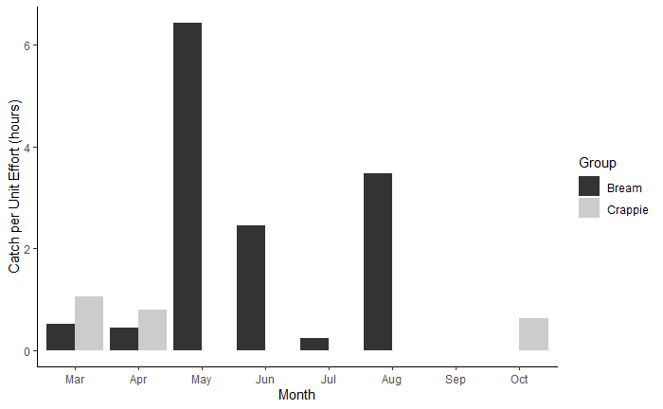

Reported angler CPUE by month and fish group

Bar plot of reported angler catch per unit effort of fish groups my month. Interviews took place at Bluff Lake, MS from March 2019-May 2020. Estimates of catch per unit effort were calculated using the ratio of means. Colors denote fish species groups.

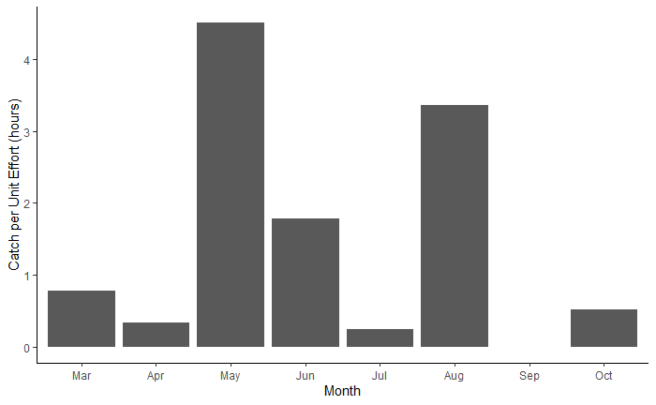

Reported angler CPUE by month

Bar plot of reported angler catch per unit effort for all fish my month. Interviews took place at Bluff Lake, MS from March 2019-May 2020. Estimates of catch per unit effort were calculated using the ratio of means.

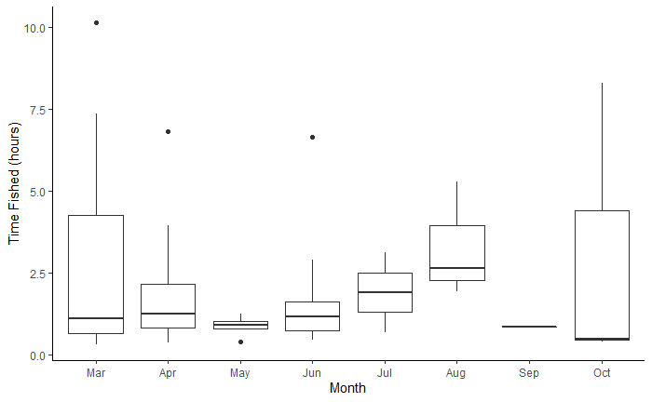

Time fished reported by anglers by month

Box plot of the time fished reported by anglers by month. Interviews took place at Bluff Lake, MS from March 2019-May 2020. Lower and upper fences are the 25th and 75th percentiles, and the median is in between. Bars represent the 10th and 90th percentiles. Closed circles represent outliers. For September, only one interview was conducted.

References

Hoenig, J. M., C. M. Jones, K. H. Pollock, D. S. Robson, and D. L. Wade. 1997. Calculation of catch rate and total catch in roving surveys of anglers. Biometrics 53:306–317.

Jennings, C. A. 1985. The effect of fishing on a previously unharvested population of largemouth bass. Master’s thesis, Mississippi State University, Mississippi State, MS.

Pollock, K. H., Hoenig, J. M., Jones, C. M., Robson, D. S. and Greene, C. J. 1997. Catch Rate Estimation for Roving and Access Point Surveys. North American Journal of Fisheries Management, 17: 11-19.



ADDITIONAL RESERVOIR USAGE INFORMATION

An alternate creel survey design was implemented from June to July 2019. Creel clerks were stationed at access points and observed vehicle wait times at each point, recorded the activity of the associated passengers, and completed interviews of anglers at the completion of their fishing trips. Although this survey design was abandoned, additional reservoir usage information was obtained from the recorded data. The following boxplot illustrates the time spent at access points by activity. The “Other” category represents unknown activities, or vehicles that were unoccupied for the entire creel wait time.

Figures

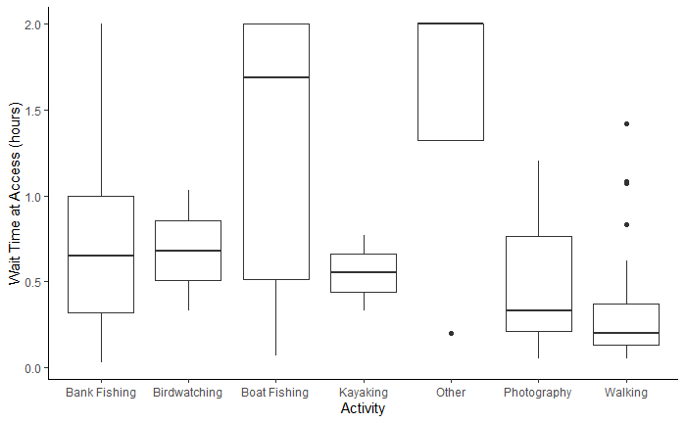

Vehicle wait times and activities of passengers

Box plot of vehicle wait times at all access points of Bluff Lake, Sam D. Hamilton Noxubee National Wildlife Refuge, Noxubee, Oktibbeha, and Winston Counties, MS by observed activity of the associated passengers for June to July 2019. Lower and upper fences are the 25th and 75th percentiles, and the median is in between. Bars represent the 10th and 90th percentiles. Closed circles represent outliers.

Hidden text to allow template to find last page in document